Number 10, May 2023
Liam Quinn, Tali Flannery, Lauren Barnaba & Sarah Bright

Trends in alleged offending by 10 to 13 year olds
This paper presents findings from Crime Statistics Agency (CSA) analysis examining young 10 to 13 year old alleged offenders recorded by Victoria Police between 1 July 2012 and 30 June 2022. It presents trends in young people’s alleged offending over time including offending frequency and offending rates. It also explores prior victimisation of alleged young offenders, which includes being recorded by police as an affected family member or child witness in a family violence incident or as a victim of crime. In this paper, young offenders are those who were aged between 10 and 13 years old at the time of offence. All references to offenders in this paper are alleged rather than proven.

1. How has the number of young offenders changed over time?
The number of unique alleged offenders aged 10, 11, 12, and 13 all decreased between 2012-13 and 2021-22.
The largest percentage decrease in alleged offenders over the past decade was for 10 year olds. Figure 1 shows the number of 10 year old unique alleged offenders decreased by 67% from 115 in 2012-13 to 38 in 2021-22. The number of unique alleged offenders aged 11 decreased from 209 in 2012-13 to 120 in 2021-22 (43% decrease). The number of unique alleged offenders aged 12 decreased from 462 in 2012-13 to 340 in 2021-22 (26% decrease). Finally, the number of unique alleged offenders aged 13 decreased from 974 in 2012-13 to 769 in 2021-22 (21% decrease).
Figure 1. Number of unique alleged offenders between 2012-13 and 2021-22, by age.
13 years old
12 years old
11 years old
10 years old
COVID-19 pandemic begins

Table 1. Demographic changes in 10 to 13 year old alleged offenders, 2012-13 to 2021-22. Table excludes unknowns.
 | 2012-13 | 2021-22
Male | 1,287 | 864
Female | 473 | 402
Aboriginal and/or Torres Strait Islander | 227 | 131
Non-Indigenous | 1,486 | 1,052
Males continue to comprise the majority of 10 to 13 year old alleged offenders (68% in 2021-22), however their numbers have decreased over time. Table 1 shows a 33% decrease in the number of male offenders from 1,287 in 2012-13 to 864 in 2021-22, and a 15% decrease in female offenders from 473 to 402.
The number of Aboriginal and/or Torres Strait Islander 10 to 13 year old alleged offenders declined over the 10 years, however the proportion of all 10 to 13 year old alleged offenders that are Aboriginal and/or Torres Strait Islander has remained relatively high. Aboriginal and/or Torres Strait Islander alleged offenders comprised 13% of offenders in 2012-13, up to 15% in 2016-17 and down to 10% in 2021-22.

2. How has the frequency of young offending changed over time?
Three-quarters of alleged young offenders were involved in only one criminal incident per year and this proportion is stable over time.
Approximately three-quarters of 10 to 13 year old alleged offenders were involved in only one police-recorded criminal incident per year, and this proportion was stable over time (76% in 2012-13, 74% in 2021-22).
A small minority of alleged young offenders were involved in multiple police incidents each year. Figure 2 shows that in 2021-22, there were just 12 alleged offenders aged 10 or 11 that were involved in three or more incidents (8% of all 10 to 11 year olds). Similarly, there were 56 (16%) 12 year old alleged offenders and 112 (15%) 13 year old alleged offenders involved in three or more incidents in that year.
Figure 2. Number of unique alleged offenders by number of incidents and age, 2012-13 to 2021-22.
2015-16
2013-14
2016-17
2014-15
2012-13
2017-18
2018-19
2019-20
2020-21
2021-22
1 incident
2 incidents
3+ incidents
1 incident
2 incidents
3+ incidents
1 incident
2 incidents
3+ incidents
10 to 11 year olds
12 year olds
13 year olds

3.How does offending by 10 to 13 year olds compare to offending among other age groups over time?
Figure 3 shows 10 to 13 year old alleged offenders were associated with a very small minority (1%) of all alleged offender incidents between 2012-13 and 2021-22, compared to 14 to 17 year olds (10%) and 18 year olds or over (88%).
Figure 3. Alleged offender incidents by age group, 2012-13 to 2021-22.
1%
9%
89%
14 to 17 year olds
10 to 13 year olds
18+ year olds
86%
12%
2%
The rate of alleged offender incidents associated with those aged 10 to 13 per 100,000 population is low relative to other age groups. For example, in 2021-22, the alleged offender incident rate for 10 year olds per 100,000 population was 62.8 (11 year olds: 219.3; 12 year olds: 717.7; and 13 year olds: 2,005.2). In contrast, for 18 year olds, the alleged offender incident rate per 100,000 population was 5,758.1.

4. What proportion of young offenders have been victims of crime or affected by family violence?
Figure 4. Proportion of 10 to 13 year old alleged offenders recorded by police as a victim of crime and/or the primary affected family member (AFM) in a family violence incident, 2021-22 (n = 1,267).
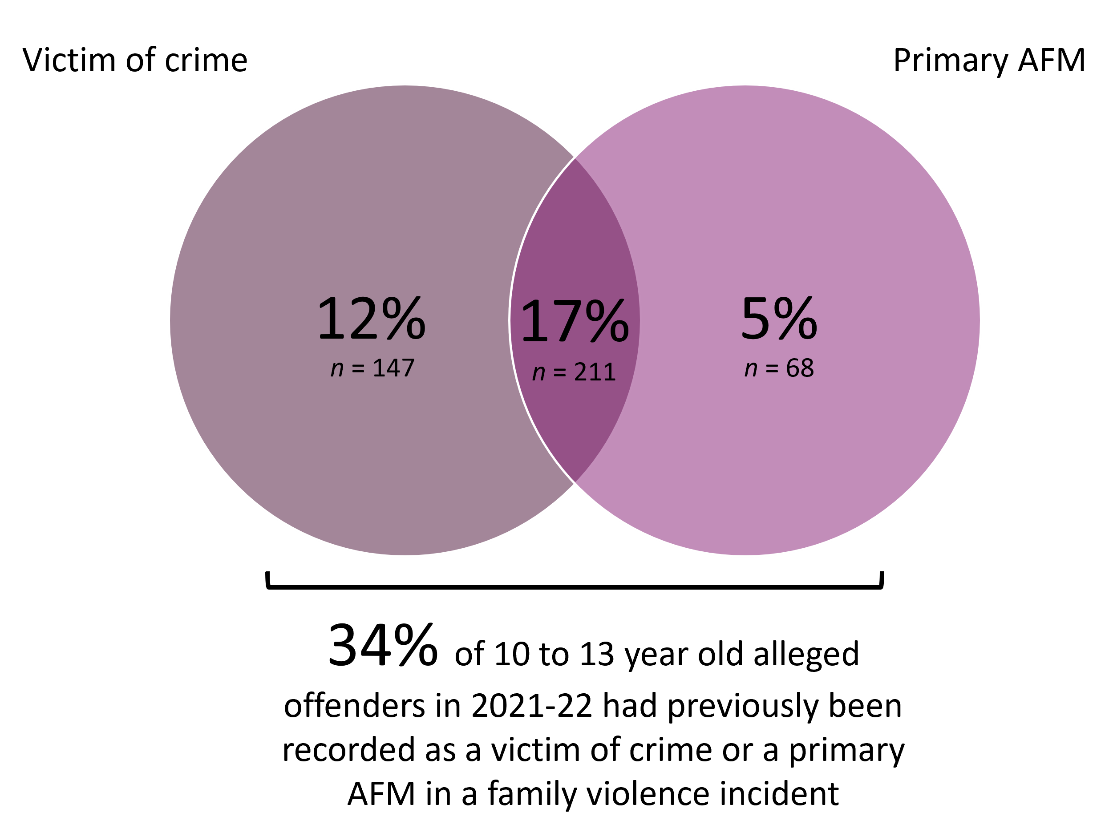
Figure 4 shows one-third (n = 426) of 10 to 13 year old alleged offenders had previous contact with police as a victim of crime and/or the AFM in a family violence incident. Further, almost half (n = 567) had been recorded as a child witness of family violence. In total, 57% (n = 722) of 10 to 13 year old alleged offenders in 2021-22 had either been recorded as a victim in a criminal incident, a primary AFM, or a child witness to a family violence incident prior to their 2021-22 alleged offence. Criminal victimisation experienced by this age group is likely underreported.

