Consultation paper: Improving recorded crime statistics for Victoria’s Aboriginal community
March 2015

June 2016

Unless indicated otherwise, content in this publication is provided under a Creative Commons Attribution 3.0 Australia Licence. To view a copy of this licence, visit creativecommons.org/licenses/by/3.0/au. It is a condition of the Creative Commons Attribution 3.0 Licence that you must give credit to the original author who is the State of Victoria.
If you would like to receive this publication in an accessible format, such as large print or audio, please telephone Crime Statistics Agency on 03 8684 1808 or email info@crimestatistics.vic.gov.au.
For further information or additional copies, please contact:
Crime Statistics Agency
121 Exhibition Street, Melbourne, VIC 3000
Tel 03 8684 1808
Contents
Acknowledgements 2
A note on terminology 2
1. Introduction 3
1.1 A priority information need 3
1.2 The challenge of data limitations 3
1.3 Role of the Crime Statistics Agency 3
1.4 About this paper 4
1.4.1 Statistics contained within this paper 4
2. Background 4
2.1 Collection of Aboriginal and Torres Strait Islander statistics within administrative data systems. 4
2.1.1 ABS Standard Indigenous Question 4
2.2 Collection of Aboriginal and Torres Strait Islander status in law enforcement crime recording systems 5
3. Current challenges 5
3.1 Analysis of missing data for Aboriginal and Torres Strait Islander Recorded Crime 5
3.2 Summary of current data quality 6
4. Future opportunities to improve Aboriginal and Torres Strait Islander recorded crime statistics 7
4.1 Improving the Input 7
4.2 Improving the output 7
4.2.1 Option 1 – Application of an ‘ever-identified’ rule 7
4.2.2 Option 2 – Application of a ‘most recent identification’ rule 8
4.2.3 Option 3 – Application of a ‘most frequent’ rule 9
4.3 Potential impacts on recorded crime statistics 11
4.4 Conclusion 13
5.1 Feedback sought in this consultation 13
References 14

Acknowledgements
The Crime Statistics Agency would like to acknowledge the contribution made to the development of this paper by representatives from Victoria Police, Department of Justice & Regulation’s Koori Justice Unit and the Department of Premier & Cabinet.

A note on terminology
The Koori Caucus of the Aboriginal Justice Forum has stated that the term ‘Koori’ is the preferred term (‘Koories’ for plural) to be used in Victoria’s Aboriginal Justice Agreement and related initiatives to describe indigenous inhabitants of Victoria. However, it should be noted that not all Aboriginal people in Victoria are necessarily of Koori background. For the purposes of this paper, Aboriginal and Torres Strait Islander is used to most accurately reflect the scope of the measurement under discussion.

Nationally the term ‘Indigenous’ has been used to describe Aboriginal and Torres Strait Islander peoples across all state and territory jurisdictions. Hence, the nationally endorsed question to be used to determine whether a person is Aboriginal or Torres Strait Islander is called the Australian Bureau of Statistics’ Standard Indigenous Question (SIQ). The resultant variable is often referred to as ‘Indigenous Status’. For consistency with usage elsewhere, when referring to the SIQ, the included responses of Aboriginal and Torres Strait Islander will be used and the resulting variable will be referred to as Aboriginal and Torres Strait Islander Status.

If quoting or referring to a source which uses different terminology, that original terminology has been retained.

1. Introduction

1.1 A priority information need
Successive Victorian Governments have affirmed their commitment to ‘close the gap’ between Aboriginal and non-Aboriginal Victorians. The Victorian Aboriginal Affairs Framework is a key organising tool in working towards this aim. Through the Victorian Aboriginal Justice Agreement (AJA), and under the guidance of the Aboriginal Justice Forum (AJF), a range of initiatives are undertaken with the aim to ensure that agencies across government can provide appropriate and responsive services to Victoria’s Aboriginal community.
Over-representation of Aboriginal and Torres Strait Islander people in the criminal justice system has long been a concern to communities and Australian governments (Weatherburn, 2014:2; Borowski, 2010). When designing policy and conducting research into the economic and social conditions of Victorians, understanding the impacts upon Aboriginal people is a key consideration. One important aspect of the Victorian Aboriginal Affairs Framework, for example, is that of measurement against key indicators to determine whether change is observable in areas of priority, including criminal justice and experience of family violence (see Victorian Aboriginal Affairs Framework 2013–2018 for examples).

1.2 The challenge of data limitations
Many indicators and evaluation activities rely upon information collected by government and other agencies during the course of their business, known as administrative by-product data. Unfortunately, it is generally believed that Aboriginal and Torres Strait Islander status is under-reported (Kennedy, Howell and Breckell, 2009; Hunter and Ayyar, 2009) and the utility of many datasets in informing about Aboriginal experiences can be curtailed by high numbers of unknown values for Aboriginal and Torres Strait Islander Status identifiers, amongst other data quality limitations. Recorded crime statistics collected by Victoria Police are an example of one data source which often suffers from a significant proportion of unknown or missing values.
“The Victorian Government places a high priority on delivering measurable results for Aboriginal Victorians. Fundamental to this is ensuring there is accurate and reliable data.”
--Victorian Government Aboriginal Affairs Report 2013, p.5
Datasets which contain a large number of unknown or missing values can pose significant challenges in the use of these data and be deemed unfit for general use. Use of data with many unknown values can lead to misleading conclusions – through either understating the true numbers of Aboriginal people identification within the dataset – and potentially ill-informed policy and decision making.

1.3 Role of the Crime Statistics Agency
The Crime Statistics Agency aims to produce high quality recorded crime statistics for the state of Victoria. The Agency has been assessing the quality of data capture relating to Aboriginal people within the recorded crime data collected by Victoria Police and exploring ways in which it may be possible to turn these data into statistics which are of sufficient quality to inform and evaluate the policies and initiatives undertaken in this state to address Aboriginal over-representation in the criminal justice system and ultimately, to close the gap.

1.4 About this paper
This paper summarises the current data quality challenges in Victoria’s recorded crime data relating to Aboriginal and Torres Strait Islander identification. We then present three different options for producing statistics where a person’s Aboriginal and/or Torres Strait Islander Status has an unknown value recorded in the Victoria Police Law Enforcement Assistance Program (LEAP), but where a meaningful ‘yes’ or ‘no’ value may have been recorded on another occasion.

1.4.1 Statistics contained within this paper
The statistics provided in this paper are for illustrative purposes only, and should not be used.

2. Background

2.1 Collection of Aboriginal and Torres Strait Islander statistics within administrative data systems.
Standards for the collection and recording of Aboriginal and Torres Strait Islander status in statistical collections stem from the Commonwealth definition for the identification of a person as an Aboriginal and/or Torres Strait Islander. There are three components:
- Aboriginal and/or Torres Strait Islander descent
- Self-identification as an Aboriginal and/or Torres Strait Islander person and
- Acceptance of the person as an Aboriginal and/or Torres Strait Islander by the community in which he or she lives.
In practice, however, the second of these components (self-identification) is used within data collection exercises as a means of assessing a person's Aboriginal and/or Torres Strait Islander Status (Kennedy, Howell and Breckell, 2009). The first and third components are not easily verifiable at the point of data collection. Self-identification is the element captured by the ABS Standard Indigenous Question.

2.1.1 ABS Standard Indigenous Question
The Australian Bureau of Statistics developed the ABS Standard Indigenous Question (SIQ) to support the collection of consistent and comparable statistics relating to Aboriginal and Torres Strait Islander people in ABS surveys and administrative data collections. It was introduced in 1996 and is used by ABS and many government and non-government agencies (ABS, 2014a; ABS, 2014b; Petry & Potts, 2014). The basic structure of the ABS SIQ is shown in Figure 1.
Figure 1. The ABS Standard Indigenous Question
[Are you] [Is the person] [Is (name)] of Aboriginal or Torres Strait Islander origin?
- No
- Yes, Aboriginal
- Yes, Torres Strait Islander
For persons of both Aboriginal or Torres Strait Islander origin, mark both Yes boxes.
Reporoduced from ABS (2014a).

If the person being asked the question refuses to answer then that is also a valid response. There can be legitimate reasons for a person to not want to respond to the SIQ. The recent review undertaken by ABS highlighted that many Aboriginal and Torres Strait Islander people did not think there was a good understanding of why the question was being asked or what the response will be used for, which could lead to unwillingness to answer the question (ABS, 2014b).
The ABS SIQ was reviewed in 2014, with the conclusion that while the wording of the current question may not be optimal, it would be retained at this time (ABS, 2014b).

2.2 Collection of Aboriginal and Torres Strait Islander status in law enforcement crime recording systems
The counting rules for the national recorded crime statistical collections require that this question be asked on each occasion of a victim report or recording as an alleged offender, wherever possible.
Over a decade ago, the ABS was leading implementation of the Indigenous identification strategy to improve the identification of Aboriginal and Torres Strait Islander people in police, criminal courts and corrective services data systems, which hinged upon the successful implementation of a standard question to allow people to self-identify as Aboriginal or Torres Strait Islander (ABS, 2005:21). Commitment was made by all state and territory policing agencies to implement the ABS Standard Indigenous Question (ABS, 2005:35). The ABS does not currently publish Victorian recorded crime data relating to Aboriginal and Torres Strait Islander status of victims and offenders from the national statistical collections, noting that they are not of sufficient quality (ABS, 2015).

3. Current challenges

3.1 Analysis of missing data for Aboriginal and Torres Strait Islander Recorded Crime
The CSA has assessed the current quality of recording for the ABS SIQ in the LEAP system and resulting recorded crime dataset. The Agency has found that there is currently poor quality Aboriginal and Torres Strait Islander Status recording in Victoria Police recorded crime data, based upon the high level of unknown values. The CSA has noted that there is a trend towards decreasing data quality for Aboriginal and Torres Strait Islander Status across many offences, as levels of unknown valuess are increasing. Table 1 shows current levels of unknown and missing data for victims, and Table 2 shows levels of unknown and missing data for alleged offenders. In both views, approximately 60% of occasions where victims or offenders are recorded by Victoria Police, the SIQ response is not recorded in LEAP.
Table 1: Victim reports by sex and Aboriginal and Torres Strait Islander status, January to December 2015
 | Aboriginal or Torres Strait Islander | Non-Indigenous | Unknown¹ | Total
Proportion (%)
Male | 0.5 | 39.7 | 59.7 | 100.0
Female | 1.2 | 39.4 | 59.3 | 100.0
Total² | 0.8 | 38.6 | 60.6 | 100.0

1 Includees unknown, not stated and missing values.
2 Includes victim reports with an unknown sex.
Data extracted from LEAP on 18 January 2016 and may be subject to variation.

Table 2: Alleged offender incidents by sex, outcome and Aboriginal and Torres Strait Islander status, January to December 2015
 | Aboriginal or Torres Strait Islander | Non-Indigenous | Unknown | Total
Proportion (%)
Male | 3.9% 32.5% 63.6% 100.0%  2.5% 25.0% 72.6% 100.0%  1.9% 54.4% 43.7% 100.0%  3.1% 32.2% 64.7% 100.0%  2.9% 46.5% 50.6% 100.0%  3.1% 34.4% 62.5% 100.0%  7.1% 30.0% 62.9% 100.0%  4.2% 22.4% 73.4% 100.0%  3.2% 52.6% 44.2% 100.0%  6.5% 27.4% 66.1% 100.0%  4.2% 45.2% 50.6% 100.0%  5.2% 32.9% 61.9% 100.0%  3.5% 34.1% 62.4% 100.0%
Arrest | 3.9 | 32.5 | 63.6 | 100.0
Summons | 2.5 | 25.0 | 72.6 | 100.0
Caution/Warning | 1.9 | 54.4 | 43.7 | 100.0
Other¹ | 3.1 | 32.2 | 64.7 | 100.0
Intent to summons | 2.9 | 46.5 | 50.6 | 100.0
Subtotal | 3.1 | 34.4 | 62.5 | 100.0
Female
Arrest | 7.1 | 30.0 | 62.9 | 100.0
Summons | 4.2 | 22.4 | 73.4 | 100.0
Caution/Warning | 3.2 | 52.6 | 44.2 | 100.0
Other¹ | 6.5 | 27.4 | 66.1 | 100.0
Intent to summons | 4.2 | 45.2 | 50.6 | 100.0
Subtotal | 5.2 | 32.9 | 61.9 | 100.0
Total² | 3.5 | 34.1 | 62.4 | 100.0

1 The category 'Other' includes penalty infringement notice, not authorised, warrant Issued, notice to appear, presentment and other statuses.
2 Includes victim reports with an unknown sex.
Data extracted from LEAP on 18 January 2016 and may be subject to variation.

There are some instances where unknown values may not indicate a data recording issue. For ex-ample, if an offender is proceeded against via summons and there may not be a face to face opportunity to ask the person the ABS SIQ, unknown values are acceptable. Table 2 provides an indication of the proportion of missing or unknown data for alleged offenders by the action that had been taken by police to that point in time. While unknown valuess are more common for offenders where a summons has been issued (72-73%), proportions of unknown values where an arrest has been recorded remain at above 60%.

3.2 Summary of current data quality
The CSA has found that there are gaps in the data currently captured by Victoria Police, suggesting that the ABS SIQ is not asked on each occasion or is not being routinely captured in the LEAP system. The Agency acknowledges that current limitations within the LEAP system make this information challenging to capture efficiently. As a result of the current data quality challenges, the Agency is not including recorded crime statistics relating to Aboriginal and Torres Strait Islander peoples in the main statistical releases, due to concerns that they may not representative.

4. Future opportunities to improve Aboriginal and Torres Strait Islander recorded crime statistics

4.1 Improving the Input
Changes to the way information is collected and stored requires commitment, and sometimes investment, to bring about cultural and procedural change. Victoria Police are planning significant information technology and business progress transformation as part of their Policing Information Process and Practice Reform Program (Victoria Police, 2015:32). This program will in part redesign Victoria Police’s IT infrastructure and related business processes. The program presents an opportunity for a future crime recording system and process to enable the easy collection and appropriate storage of this information.

4.2 Improving the output
While the quality of the data input by Victoria Police members in relation to Indigenous Status remain at current levels, the Crime Statistics Agency has identified three possible options for presenting this information. These methods may artificially ‘improve’ the completeness of this data through various methods of imputation and derivation. These methods involve in some way using assumptions from available pieces of information to ‘fill in the gaps’ of the missing data.
In some instances, these methods may result in false positive indentifications (for example, a person being identified as Aboriginal and/or Torres Strait Islander on an occasion when they may not have self-identified as Aboriginal and/or Torres Strait Islander, if they had the opportunity to do so. In other instances, there may be some false negative identifications (where a person is not identified as Aboriginal and/or Torres Strait Islander, but they may have self-identified as Aboriginal and/or Torres Strait Islander if they had the opportunity to do so). Data entry errors may also impact upon the accuracy of the data produced through these methods.All of these methods involve a compromise between a desire to improve the data to make it more meaningful or fit for use maintaining the ability for people to self-identify as Aboriginal and/or Torres Strait Islanders within an interaction.
The three options for consideration are:
• an ‘ever-identified’ rule
• a ‘most recent identification’ rule
• a ‘most frequent’ rule.

4.2.1 Option 1 – Application of an ‘ever-identified’ rule
Under this rule, if a person is identified on one occasion as Aboriginal and/or Torres Strait Islander in the current recorded crime dataset, then this identification is carried across all of the person’s other records in the dataset. This applies regardless of whether the person is asked their status as a victim or an offender. Figure 2 provides an illustration of one scenario where this counting rule has been applied.
This technique reduces the number of unknown values for people with at least one meaningful response recorded for the ABS SIQ (Yes or No) and who have multiple appearances in the dataset. The ever-identified rule has received criticism in some applications, however. This is primarily because it may in fact “lead to potentially spurious over-identification” of Aboriginal and/or Torres Strait Islander people (Shahidullah, 2012). This criticism arises because one single data entry error could be sufficient to erroneously identify a person as an Aboriginal or Torres Strait Islander across all instances within a dataset. This method is therefore particularly sensitive to any deficiencies in the quality of data entry or consistency in asking the ABS SIQ.
Figure 2. Illustrative example of an 'ever Identified' derivation rule to output from the Aboriginal and/or Torres Strait Islander status variable
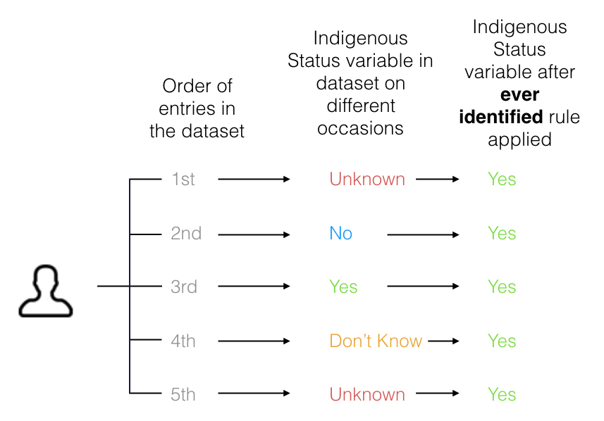
Additionally, as self-identification is a crucial component of the ABS SIQ, use of this method does not allow for a person to change or reaffirm their Aboriginal and/or Torres Strait Islander Status over time or in different circumstances, which they may wish to do (Kennedy, Howell and Breckell, 2009).

4.2.2 Option 2 – Application of a ‘most recent identification’ rule
Using the most recent identification method, a person’s most recently provided response to whether or not they identify as being of Aboriginal and/or Torres Strait Islander is carried across all of the person’s previous records in the dataset. See Figure 3, below for an illustration of a scenario where this counting rule has been applied.

FIGURE 3. Example A of the application of a ‘most recent’ ‘derivation rule to output from the Aboriginal and/or Torres Strait Islander status variable relating to a victim or an offender
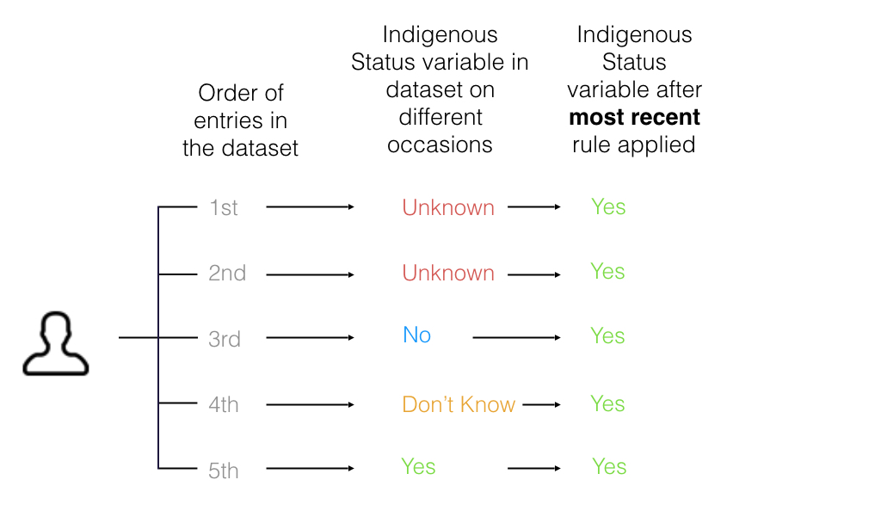
Use of the most recent identification does enable an individual to change their personal self-identification as Aboriginal andor Torres Strait Islander, as the most contemporary record is selected to represent the person. This method is also highly sensitive to data entry errors, as one single data entry error could erroneously carry through to all of the records relating to a person (as illustrated below in Figure 4).
FIGURE 4. Example A of the application of a ‘most recent’ ‘derivation rule to output from the Aboriginal and/or Torres Strait Islander status variable relating to a victim or an offender
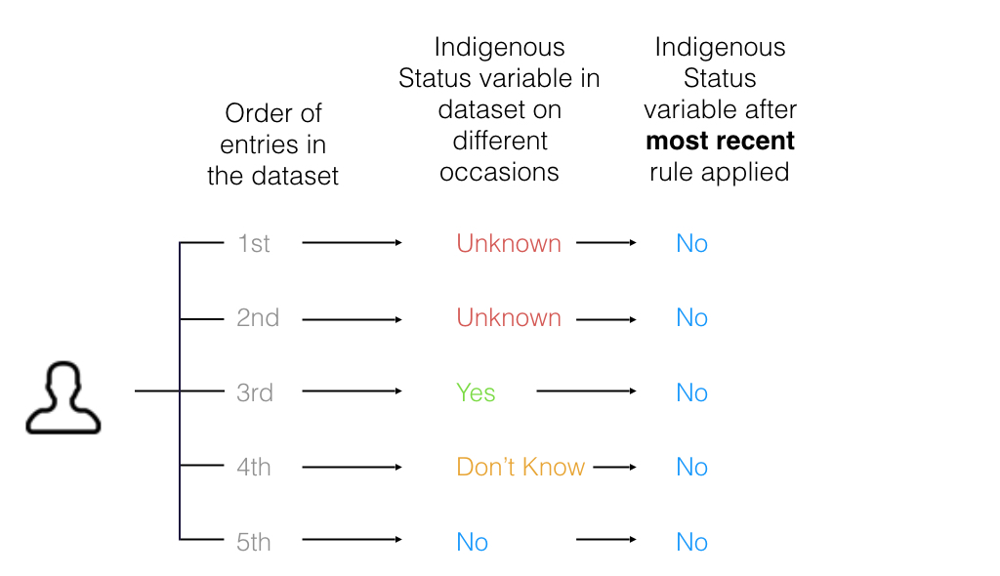

4.2.3 Option 3 – Application of a ‘most frequent’ rule
Under this counting rule, a person has either a yes or no response to the SIQ on their record, then the most frequently appearing response is taken as correct. If the person only has one meaningful response (‘yes’ or ‘no’), then that response stands across all records. If a person appears in the dataset two different times with a ‘yes’ and a ‘no’ in the records, a ‘yes’ response is taken over a ‘no’ response. Figures 5 and 6 illustrate how this counting rule operates in two different scenarios.
A most frequent response may be less susceptible to data entry error than the previous methods, as a person with a number of appearances would require multiple incorrect responses in the dataset for their records to be incorrectly assigned, and it is less likely to occur based upon a single incorrect entry. The more entries a person has in the dataset, the greater the likelihood that their data is correct. The only exception to this would be where a person wishes to change the way they identify and respond to the question over time. This would not be recognised until the majority of a person’s entries in the database reflected their current status. This rule is also dependent upon the SIQ being asked on each occasion.
Figure 5. Illustrative example of the application of a ‘most frequent’ derivation rule to output from the Aboriginal and/or Torres Strait Islander status variable relating to a victim or a offender
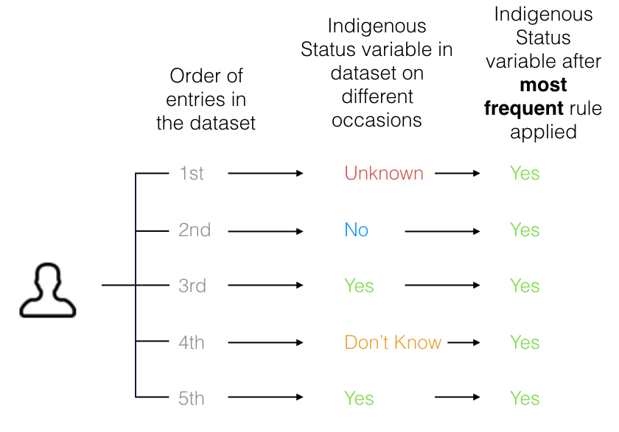
Figure 6. Illustrative example of the application of a ‘most frequent’ derivation rule to output from the Aboriginal and/or Torres Strait Islander status variable relating to a victim or a offender
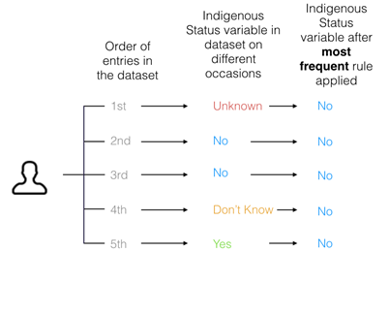

4.3 Potential impacts on recorded crime statistics
To illustrate the impacts of these different techniques on recorded crime statistics, sample data from the CSA recorded crime dataset from April 2009 to March 2015 is presented below in the three different views:
1) data derived using the ever-identified rule
2) data derived using the most recent rule
3) data derived using the most frequent rule.

The ever-identified rule shows the greatest reduction in unknown values, although as previously noted, it is also susceptible to producing false positive results where data entry or recording errors in the dataset may exist. The impact of this counting rule on the recorded crime data is illustrated in Table 3.
Table 3: Alleged offender counts by Aboriginal and/or Torres Strait Islander status, January to December 2015, produced using the ‘ever-identified’ counting rule
 | 2010 | 2011 | 2012 | 2013 | 2014 | 2015
Proportion (%)
Aboriginal | 9.4  2.5% 63.6% 100.0%  2.5% 25.0% 72.6% 100.0%  1.9% 54.4% 43.7% 100.0%  3.1% 32.2% 64.7% 100.0%  2.9% 46.5% 50.6% 100.0%  3.1% 34.4% 62.5% 100.0%  7.1% 30.0% 62.9% 100.0%  4.2% 22.4% 73.4% 100.0%  3.2% 52.6% 44.2% 100.0%  6.5% 27.4% 66.1% 100.0%  4.2% 45.2% 50.6% 100.0%  5.2% 32.9% 61.9% 100.0%  3.5% 34.1% 62.4% 100.0% | 10.0 | 9.9 | 9.9 | 10.3 | 10.7
Both Aboriginal and Torres Strait Islander | 2.5 | 2.9 | 2.9 | 3.1 | 3.4 | 3.5
Neither Aboriginal or Torres Strait Islander | 84.0 | 83.1 | 82.9 | 82.9 | 82.4 | 82.1
Torres Strait Islander | 1.3 | 1.4 | 1.5 | 1.6 | 1.6 | 1.4
Missing | 2.2 | 2.1 | 1.7 | 1.7 | 1.5 | 1.5
Unknown¹ | 0.7 | 0.6 | 1.1 | 0.9 | 0.9 | 0.9
Total | 100.0 | 100.0 | 100.0 | 100.0 | 100.0 | 100.0

Data extracted from LEAP on 18 January 2016 and may be subject to variation.
1 Includes unknown and not stated values.

The second possible method, the 'most recent' counting rule, effectively represents the current state of the recording of the Aboriginal and/or Torres Strait Islander status of victims and offenders within the dataset. Table 4 shows an illustration of the possible impact of this counting rule on the dataset.
The third method, the 'most frequent' counting rule, also produces significant reductions in unknown values, and may be less susceptible to producing false positive results in Aboriginal and/or Torres Strait Islander identification in cases of data entry or recording error. The possible impact of this counting rule is shown in Table 5.
Table 4: Alleged offender counts by Aboriginal and/or Torres Strait Islander status, January to December 2015, produced using the ‘most recent’ counting rule
 | 2010 | 2011 | 2012 | 2013 | 2014 | 2015
Proportion (%)
Aboriginal | 3.2  2.5% 63.6% 100.0%  2.5% 25.0% 72.6% 100.0%  1.9% 54.4% 43.7% 100.0%  3.1% 32.2% 64.7% 100.0%  2.9% 46.5% 50.6% 100.0%  3.1% 34.4% 62.5% 100.0%  7.1% 30.0% 62.9% 100.0%  4.2% 22.4% 73.4% 100.0%  3.2% 52.6% 44.2% 100.0%  6.5% 27.4% 66.1% 100.0%  4.2% 45.2% 50.6% 100.0%  5.2% 32.9% 61.9% 100.0%  3.5% 34.1% 62.4% 100.0% | 3.4 | 3.2 | 3.0 | 3.2 | 3.2
Both Aboriginal and Torres Strait Islander | 0.1 | 0.1 | 0.2 | 0.1 | 0.1 | 0.1
Neither Aboriginal or Torres Strait Islander | 40.7 | 39.4 | 39.9 | 38.4 | 37.8 | 33.3
Torres Strait Islander | 0.1 | 0.1 | 0.1 | 0.1 | 0.1 | 0.1
Missing | 30.4 | 31.4 | 30.6 | 32.4 | 32.5 | 38.0
Unknown¹ | 25.5 | 25.5 | 26.1 | 26.0 | 26.2 | 25.3
Total | 100.0 | 100.0 | 100.0 | 100.0 | 100.0 | 100.0

Data extracted from LEAP on 18 January 2016 and may be subject to variation.
1 Includes unknown and not stated values.
Table 5: Alleged offender counts by Aboriginal and/or Torres Strait Islander status, January to December 2015, produced using the ‘most frequent’ counting rule
 | 2010 | 2011 | 2012 | 2013 | 2014 | 2015
Proportion (%)
Aboriginal | 5.5  2.5% 63.6% 100.0%  2.5% 25.0% 72.6% 100.0%  1.9% 54.4% 43.7% 100.0%  3.1% 32.2% 64.7% 100.0%  2.9% 46.5% 50.6% 100.0%  3.1% 34.4% 62.5% 100.0%  7.1% 30.0% 62.9% 100.0%  4.2% 22.4% 73.4% 100.0%  3.2% 52.6% 44.2% 100.0%  6.5% 27.4% 66.1% 100.0%  4.2% 45.2% 50.6% 100.0%  5.2% 32.9% 61.9% 100.0%  3.5% 34.1% 62.4% 100.0% | 5.9 | 5.5 | 5.4 | 5.5 | 5.9
Both Aboriginal and Torres Strait Islander | 0.0 | 0.0 | 0.0 | 0.0 | 0.0 | 0.0
Neither Aboriginal or Torres Strait Islander | 84.9 | 83.9 | 83.3 | 82.2 | 80.6 | 78.8
Torres Strait Islander | 0.1 | 0.1 | 0.1 | 0.1 | 0.1 | 0.1
Missing | 4.6 | 4.6 | 4.2 | 4.8 | 4.9 | 5.1
Unknown¹ | 4.9 | 5.4 | 6.8 | 7.6 | 8.8 | 10.2
Total | 100.0 | 100.0 | 100.0 | 100.0 | 100.0 | 100.0

Data extracted from LEAP on 18 January 2016 and may be subject to variation.
1 Includes unknown and not stated values.

4.4 Conclusion
All three of the proposed output counting rule options presented have advantages and disadvantages. They may result in under or over estimations of Aboriginal and/or Torres Strait Islander status depending on the quality of the raw data that is recorded. None of these methods can 'fix' weaknesses in the underlying dataset as recorded. Instead, in using these methods we make assumptions about what missing values may have been, based upon what can be observed in the records that are present.
Fundamentally, the effectiveness of any of these counting rules in improving the coverage in recorded crime statsitics for Aboriginal and Torres Strait Islander peoples is dependent upon the quality of the data recorded and stored by Victoria Police. Any significant changes to these practices or data quality in the future may require a reconsideration of the output methods used.

5.1 Feedback sought in this consultation
In this paper, we have presented some examples of the current levels of missing values in the recorded crime dataset for Aboriginal and Torres Strait peoples, and several options for calculating output which may minimise these effects.
The CSA is currently considering the options outlined above for application to Victoria’s official recorded crime statistics released to the public and policy makers. All three options have limitations, but may also provide some improvements to the datasets, enabling greater use of the data by reducing the very high rates of ‘unknown’ responses in the data as originally recorded by Victoria Police. As the fundamental element of the ABS SIQ is self-identification, however, it is crucial that the methodology used to produce recorded crime statistics about Aboriginal and Torres Strait Islander peoples is acceptable to the Victorian Aboriginal comment. The CSA welcomes feedback on these proposals from the Victorian Aboriginal community and any other interested stakeholders. The CSA will consider all feedback received prior to adopting any of the proposed methodologies for the purposes of deriving recorded crime statistics. Feedback will also explicitly be sought through relevant forums.
Any feedback on these proposals is welcomed by 5PM on 15 July 2016. You can provide feedback to the CSA by any of the following methods:
By mail -
Chief Statistician
Crime Statistics Agency
GPO Box 4356
MELBOURNE VIC 3001
By phone -
(03) 8684 1808
By email:
info@crimestatistics.vic.gov.au

References
Australian Bureau of Statistics (2014a) Indigenous Status Standard, 2014, (cat. no. 1200.0.55.008 , Version 1.5. URL: http://www.abs.gov.au/ausstats/abs@.nsf/mf/1200.0.55.008 Date published: 8 October 2014 Date retrieved: 7 January 2016.
Australian Bureau of Statistics (2014b) Information Paper: Review of the Indigenous Status Standard, 2014. (cat. no. 4733.0) Australian Government: Canberra. URL: http://www.abs.gov.au/AUSSTATS/abs@.nsf/Lookup/4733.0Main+Features32014?OpenDocument Date published: 08/10/2014 Date retrieved: 7 January 2016.
ABS (2005) National Information Development Plan (cat. No. 4520.0). Australian Government: Canberra.
Australian Bureau of Statistics (2015) Recorded Crime - Victims, Australia 2014 (cat. no. 4510.0). URL: http://www.abs.gov.au/AUSSTATS/abs@.nsf/Lookup/4510.0Explanatory%20Notes12014?OpenDocument Date published: 22 July 2015. Date retrieved: 3 April 2016.
Borowski, A. (2010) ‘Indigenous Participation in Sentencing Young Offenders: Findings from an Evaluation of the Children's Koori Court of Victoria’, Australian & New Zealand Journal of Criminology, December 2010, 43:3, 465-484.
Hunter, B. H. & Ayar, A. (2009) Some reflections on the quality of administrative data for Indigenous Australians: The importance of knowing something about the unknown(s). CAEPR Working paper no. 51/2009. Australian National University: Canberra.
Kennedy, B., Howell, S., & Breckell, C. (2009) Indigenous identification in administrative data collections and the implications for reporting Indigenous health status, Technical report no. 3, April. Queensland Health.
Petry, B. and Potts, E. (2014) 'Measuring indigenous populations across nations: Challenges for methodological alignment', Statistical Journal of the IAOS. V30, pp.55-63.
Shahidullah, M. (2012) ‘Response: ABS’s comments on ‘estimating Indigenous life expectance: pitfalls with consequences’, Journal of Population Research, Vol 29, pp 283-287.
State Government of Victoria (2013) Victorian Aboriginal Affairs Framework 2013-2018. State Government: Melbourne.
Victoria Police (2015) Annual Report 2014-15. State Government: Melbourne.
Weatherburn, D. (2014) Arresting Incarceration: Pathways out of Indigenous Incarceration. Aboriginal Studies Press: Canberra.

onsec tetuer nonummy nibh Euismod tincidunt ut laoreet nonummy nibh euismod tincidunt ut lammy nibh euismod tincidunt ut laoreet adipiscing elit, sed vel eum dolor in hendr nostridism erit hendrerit vulputate.
Colore magna Dolor hendrerit in Vulputate velit esse molestie vulputate velit esse molestie laoreet dolore erat. Dolor sit amet, con dsectetuer autem Lorem ipsum dolor sit consectetuer quis.
Cuis autem vel eum iriure dolor in Consectetuer adipiscing hendrerit vulputate velit esse molestie.
Dolore magna Dolor hendrerit in Bulputate velit esse molestie vulputate velit sit amet, con dsectetuer autem Lorem ipsum dolor sit consectetuer quis nostrud hendr nostr idism erit hendrerit vulputate. Doem Lorem ipsum dolor sit consectetuer quis nostrud exerci ullamcorper sus vel eum dolor in hendr.

