Long-term trends in Property and deception crimes in Victoria
Year ending 31 March 2021

Unless indicated otherwise, content in this publication is provided under a Creative Commons Attribution 4.0 International Licence. To view a copy of this licence, visit creativecommons.org/licenses/by/4.0. It is a condition of the Creative Commons Attribution 4.0 International Licence that you must give credit to the original author who is the Crime Statistics Agency.
If you would like to receive this publication in an accessible format, such as large print or audio, please telephone Crime Statistics Agency on 03 8684 1808 or email info@crimestatistics.vic.gov.au.
For further information or additional copies, please contact:
Crime Statistics Agency
121 Exhibition Street, Melbourne, VIC 3000
Tel 03 8684 1808

Contents
1. Introduction 3
1.1 Scope 3
2. How property crimes influence overall recorded crime statistics trends 4
2.1 The long-term decrease of Burglary/Break and enter offences 6
2.2 The volatility in theft offences 7
2.3 Property items stolen 7
3. Discussion 10
References 11

1. Introduction
In Victoria, when overall levels of recorded crime change, it is often driven by changes in property and deception offences, specifically theft categories due to their volume. Theft is the most common property offence recorded and often constitutes the majority of the offences recorded by police. Some categories of Property and deception offences in Victoria have shown long-term decreases. This aligns with findings interstate: a recent study by the NSW Bureau of Crime Statistics and Research found that Motor vehicle theft, Break and enter non-dwelling and dwelling had significantly decreased by at least 85% in the last 25 years (Goh & Ramsey, 2021).

Short-term volatility can also be seen in this category, however. We have also recently observed some dramatic changes in Victoria’s Property and deception offence levels, coinciding with the impacts of the COVID-19 pandemic and associated public health response. Crime Statistic Agency (CSA) research found overall decreases in Property and deception offences committed in 2020, with decreases specifically in acquisitive offences relating to theft such as Motor vehicle theft, Steal from a motor vehicle, Steal from retail store and Other theft (Burgess, Nguyen, Chai & Kelly, 2021). In the year ending 31 December 2020, Property and deception offences decreased 12.1% (36,964 offences) however the effect of this decrease on overall crime levels was offset by 37,505 Breach of Chief Health Officer (CHO) directions offences directly related to the public health response to the pandemic (first recorded in 2020).
This spotlight will explore longer-term trends in this category, exploring changing patterns in offences and property characteristics and noting more recent, dramatic changes correlated with the effects of the global pandemic.

1.1 Scope
CSA data holdings include 16 years of Victorian recorded crime trend data that is inclusive of all criminal acts for which a penalty could be imposed by the Victorian legal system. This spotlight presents data relating to Property and deception offences recorded by Victoria Police in the Law Enforcement Assistance Program (LEAP) database. The CSA has access to LEAP data from July 2005 and data for this spotlight were extracted on 18 April 2021. Data will be presented for 12 month periods from April 2005 to March 2021. All references to offence types in this paper are based on the CSA Offence Classification Index (CSA, 2015).
The primary measure of recorded crime featured in this paper is the recorded offence count except for the number of property items stolen. The offence count represents every instance that an alleged violation of criminal legislation has been recorded by Victoria Police in the LEAP database. The property item represents each distinct property item recorded with an offence.

2. How property crimes influence overall recorded crime statistics trends
In the last 16 years, Victorian crime statistics show two small peaks in recorded offences: 2016-17 and 2019-20. The figure below shows the overall decrease of 1.8% in recorded offences in the past 12 months, and highlights an 8.8% decrease for the offence types not directly related to COVID-19 and breaches of the CHO directions. These offences are a direct result of Victoria Police’s enforcement activities related to the COVID-19 pandemic public health response and are not usually a feature of Victoria’s recorded crimes. The decrease in recorded criminal offences in the last 12 months was driven by drops in high volume acquisitive crimes in Property and deception offences, which decreased by 59,773 offences or 19.1%.
The figure below also shows that Property and deception offences have decreased by 11.0% in the last 16 years to the lowest volume of property and deception offences recorded in the CSA’s data holdings (in 2020-21). The overall proportion of all offences that are Property and deception offences has decreased to 47.6% in the most recent year from a high of 75.0% in the year ending 31 March 2007. This proportional change also reflects the growth in the volume of Crimes against the person, Drug offences, Public order and security offences and Justice procedure offences over the same time period.
Recorded offences - Victoria, April 2005 to March 2021
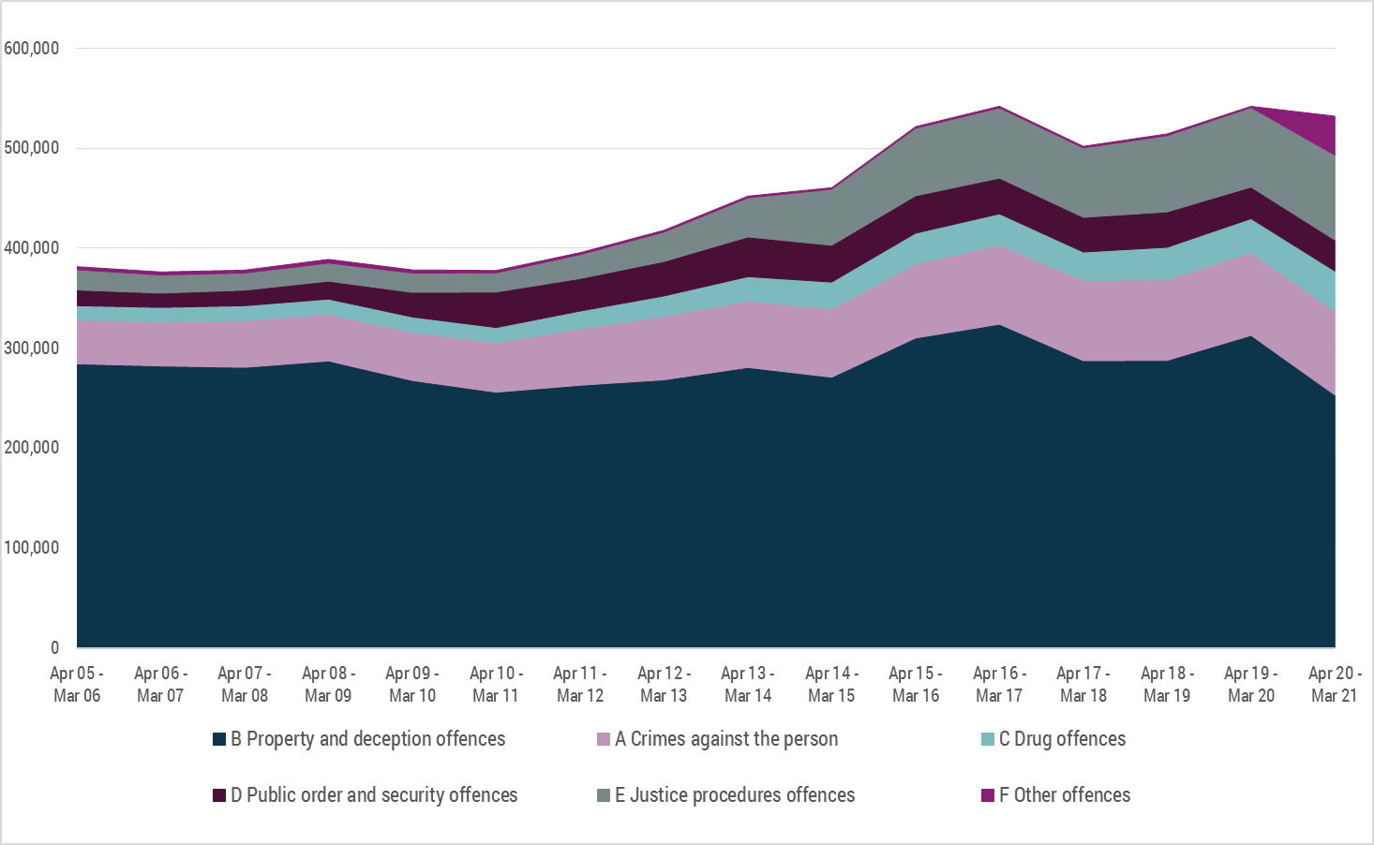
Source: Crime Statistics Agency – Recorded offences, Victoria – year ending 31 March 2021
Note: The majority of F92 Public health and safety offences are COVID-19-related offences (Breaches of Public Health Officer Directions) (99.9% in 2021).
Despite interest in the longer-term trends in this spotlight, the sharp decrease in the last 12 months is notable. CSA analysis undertaken early in the pandemic found that COVID-19-related restrictions and changes in movements appeared to have had flow on effects on crime, with lower than forecast numbers recorded for acquisitive offence types in particular (Rmandic, Walker, Bright and Millsteed, 2020; Gare, Bright, Barnaba, Phillips and Millsteed, 2020; Burgess, et al., 2021).
This emerging research has been replicated in other jurisdictions and countries that have experienced periods of public health-related movement restrictions, with similar results. While NSW did not experience the same severity or duration of restrictions on movements through the pandemic response in 2020, early research found declines in acquisitive crime types in NSW (Kim & Leung, 2020). In the UK similar trends have been found during lockdown periods, with declines in most crime types; particularly in acquisitive crime and robbery (Langton, Dixon & Farrell, 2021; Office for National Statistics, 2021). The early research into the COVID-19 pandemic has found that changes to guardianship, people’s movements and routine activities have driven decreases in recorded crime offence trends, especially in the high-volume Property and deception-related offence types, such as theft.
In line with decreases in acquisitive offence types observed in previously published CSA analysis, and in other jurisdictions, Property and deception offences decreased sharply during this period from April 2020 to March 2021 in Victoria. As noted in the figure below, the overall decrease in the last 12 months was driven by Theft (down 44,402 offences or 23.4%) and Burglary/Break and enter offences (down 12,739 offences or 29.3%). Theft offences made up the majority of Property and deception offences (57.6% in the last 12 months).
CSA Recorded offences, Property and deception offences - Victoria, April 2005 to March 2021
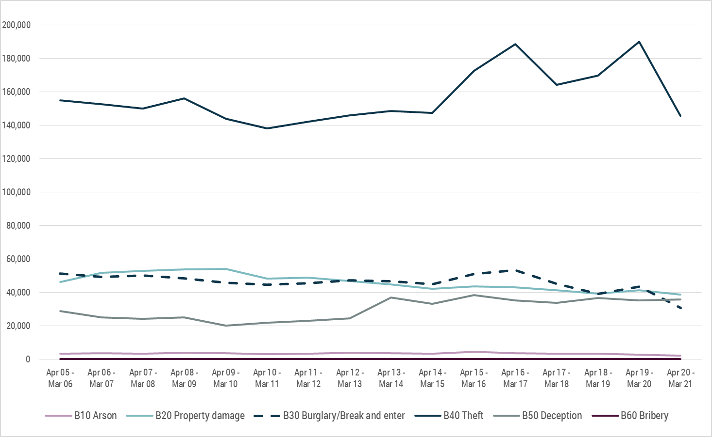
Source: Crime Statistics Agency – Recorded offences, Victoria – year ending 31 March 2021
The overall trends for Theft and Burglary/Break and enter offences have mirrored that of the overall Property and deception category and substantial decreases have been seen in these offence groups.

2.1 The long-term decrease of Burglary/Break and enter offences
Despite some fluctuations in the last 16 years, Burglary/Break and enter offences have been on an overall downward trend in the last 16 years, down 40.1% (20,566 offences) to the year ending 31 March 2021. The majority of the offences in this category are Non-aggravated burglary and the overall decrease is due to these offences (down 45.5% or 22,576 offences). Aggravated burglary has increased 113.9% in the last 16 years (2,010 offences) but still remains a much lower volume category than Non-aggravated burglary. There is a substantial volume difference in the decrease in Non-aggravated burglary and the increase in Aggravated burglary, suggesting that there is more than a simple displacement effect of Non-aggravated burglaries escalating to the aggravated category at play.
Non-aggravated burglary decreased 31.0% in the last 12 months. With changed guardianship of homes and reduced population mobility given stay at home restrictions in place for a significant proportion of the year, there was likely reduced opportunity to commit non-aggravated burglaries.
CSA Recorded offences, Burglary/Break and enter offences - Victoria, April 2005 to March 2021
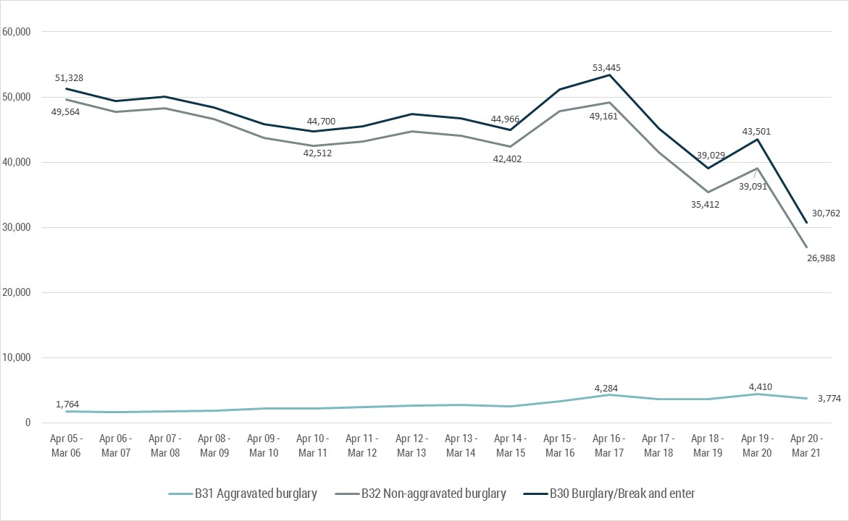
Source: Crime Statistics Agency – Recorded offences, Victoria – year ending 31 March 2021

2.2 The volatility in theft offences
In the last 16 years, Theft offences decreased slightly after 2006, however, since the year ending 31 March 2011 Theft offences have been on an upward trend to a second peak in the year ending 31 March 2020. The high volume offence types that drove these upward trends were Other theft and Steal from a motor vehicle. The former has been decreasing overall (down 29.7% or 16,652 offences) across the last 16 years while the latter has been increasing (up 3.4% or 1,591 offences).
Other theft offences have been volatile across the available time series, as shown in the figure below, recording its highest peak since 2014 in the year ending 31 March 2020, up 18.4% or 8,117 offences from a previous low in the year ending 31 March 2015. Conversely, Steal from a motor vehicle had been increasing from its lowest recorded number in the year ending 31 March 2013, up 51.6% or 22,873 offences to its peak in the year ending 31 March 2017.
CSA Recorded offences, select Theft offences - Victoria, April 2005 to March 2021
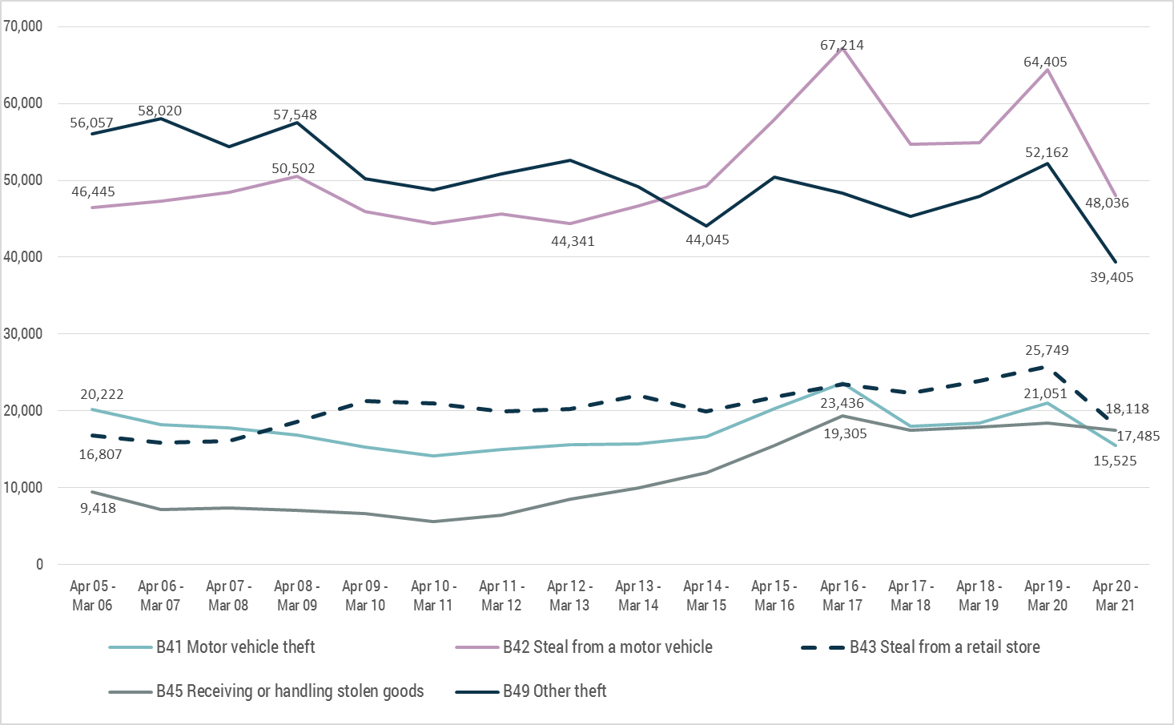
Source: Crime Statistics Agency – Recorded offences, Victoria – year ending 31 March 2021

2.3 Property items stolen
The figure below displays the number of property items recorded as stolen for Theft and Burglary/Break and enter offences. There are more property items recorded by Victoria Police as stolen than theft and burglary offences, as an offence may have multiple items listed as stolen.
When Victoria Police receive a report of Theft or Burglary/Break and enter, there may be insufficient detail immediately available to complete the property item report. This includes victims of crime that are unaware of the property items that have been stolen at the time of reporting, for example, they may not notice something is missing until they go to use it later on and it is not there. Police recording procedures require the report to be submitted as soon as sufficient details are available, however victims may not always provide these and therefore are not added to the incident. A small portion of reports may require Victoria Police data entry staff to enter the details into Victoria Police systems instead of direct recording by members. These processes can mean it takes longer for reports to be entered into the system. Victoria Police have also advised that, over time, there has been a reduction in the number of property item reports submitted for theft and burglary/break and enter offences, and a proportion of offences do not have any property items recorded. This proportion has been increasing in recent years and is particularly marked in the year ending 31 March 2021. As a result the data related to property items may not reflect all items that have been stolen but reflects the most complete data available at the time of extraction.
The overall number of property items stolen has followed the same trend as the overall offence trends, a peak in volume in the year ending 31 March 2017 and to a lesser extent in the year ending 31 March 2020, followed by sharp drop of 35.6% to the year ending 31 March 2021. The decline in Theft and Burglary/Break and enter offences was not as sharp as the items stolen (down 24.5% or 57,141 offences).
Number of property items stolen in Theft and Burglary/break and enter offences - Victoria, April 2005 to March 2021
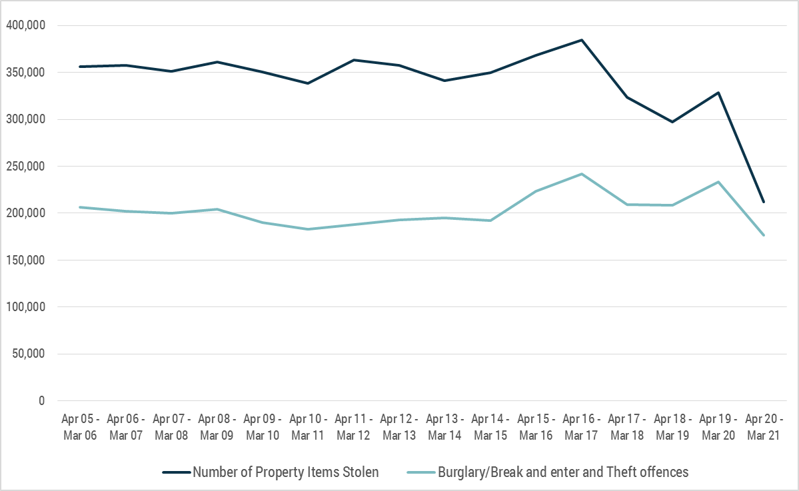
Source: Crime Statistics Agency – Recorded offences, Victoria – year ending 31 March 2021
Note: Data quality issues have been identified with the property items stolen variable. There has been a reduction in the number of property item reports submitted for Theft and Burglary/break and enter offence types over time and some offences do not have any property types recorded at all. Please note that the data related to property items may not reflect all items that have been stolen but reflects the most complete data available at the time of extraction.
The decrease in property items stolen was driven by a drop in Other property items (down 39.7% or 21,353 items), Personal property items (down 38.1% or 15,641 items), Jewellery (down 63.5% or 14,811 items) and Cash/Documents (down 31.4% or 13,985 items).
Most of the recorded stolen property items were taken from residential locations. The decrease in the last 12 months in the Residential non-aggravated burglary offence type has contributed to less stolen property reports (down 30.9%). The dramatic decreases observed in the last 12 months may be attributable to COVID-19-related disruptions and subsequent changes in opportunity and guardianship of property. Changes in the last 12 months should be interpreted with caution as more time is required to measure the full impacts of COVID-19-related disruptions on overall recorded crime trends and whether these trends continue.

The figures below illustrate that items that hold their value, such as cash, continue to be stolen in Victoria but in the year ending 31 March 2017 the number of jewellery items stolen started to decrease rapidly, down 49.4% or 22,816 items to the year ending 31 March 2020. Upon further investigation jewellery was more likely to be associated with Non-aggravated burglary offences and this offence type has been decreasing, down 20.5% from the year ending 31 March 2017 to 2020.
In the year ending 31 March 2017, computers started to decline as a stolen property item while laptop/tablet increased. Similar trends are evident for Photographic equipment, Mobile phones, MP3 player/iPod, TV/VCR and Video game categories, all increased when introduced to the market and desirability for these items and their value was highest, but over time the numbers of these items stolen have decreased, especially as newer technologies have replaced them.
Select property items stolen in Theft and Burglary/break and enter offences - Victoria, April 2005 to March 2021
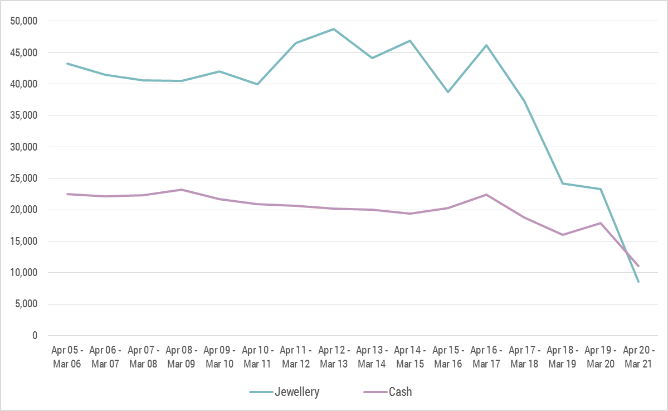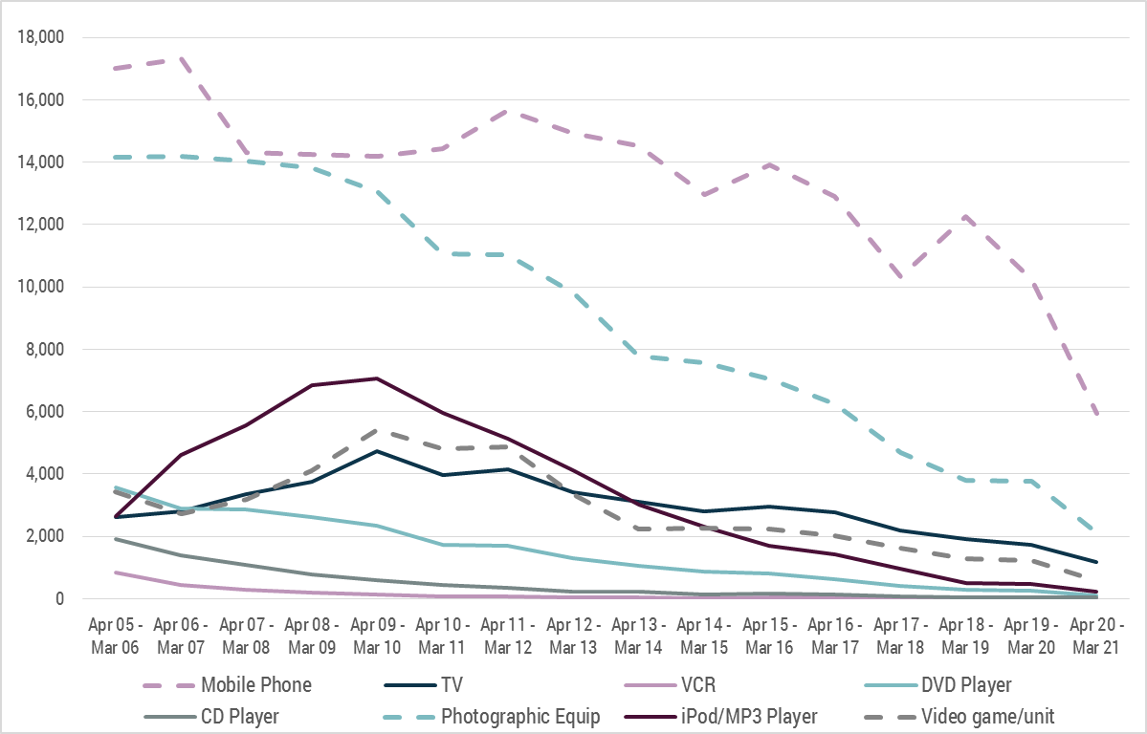
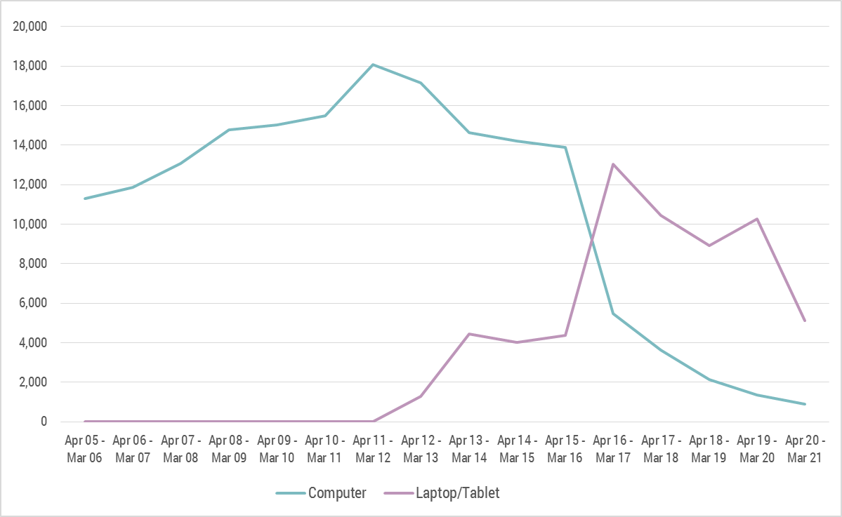
Source: Crime Statistics Agency – Recorded offences, Victoria – year ending 31 March 2021
Note: Data quality issues have been identified with the property items stolen variable. There has been a reduction in the number of property item reports submitted for Theft and Burglary/break and enter offence types over time and some offences do not have any property types recorded at all. Please note that the data related to property items may not reflect all items that have been stolen but reflects the most complete data available at the time of extraction.
This spotlight includes information about select property types, for more property items please see the excel file and the data visualisation on the website, including information about farm crimes and number plate thefts.

3. Discussion
In the last 16 years, Victorian crime statistics show an overall increasing trend for all offences, however the proportion of Property and deception-related offences has decreased. This proportional change also reflects the growth in the volume of Crimes against the person, Drug offences, Public order and security offences and Justice procedure offences over the same time period. In the last 12 months the overall recorded crime numbers have been driven down by the dramatic decrease in Property and deception offences.
The recent decline in Victorian recorded crime coincides with COVID-19-related disruptions, possibly reflecting changes in guardianship of property as people were at home more often and mobility was reduced, changing criminal offending opportunities for some crime types. These decreases were especially evident in the acquisitive offence types, Property and Deception-related offences. When examining the Property and Deception-related offences it was found that there were differing trends in acquisitive offence types, Theft and Burglary/Break and enter, the latter decreasing over time while the former was increasing. Looking at the different Theft offence types revealed further contrasting trends, Motor vehicle theft remained relatively stable, Steal from a motor vehicle was trending up and Other theft was trending down in the last 16 years.
When exploring the types of property items stolen it was evident that items started to decrease as they were replaced by other devices, for example computers with laptops/tablets and the decline in theft of photographic equipment as other devices have taken on the role of cameras. And others appeared to decrease as they were replaced with other items that are carried on the person rather than stored at home, for example decreases in photographic equipment, CD players and MPS players/iPods. It is difficult to pinpoint the reasons why mobile phone theft decreased over time given the ubiquity of these devices and increases in functionality over time. It may be attributable to the increases in security on these devices, on the other hand, it may be the shortened life cycle of phones.
The long-term Victorian experience of the acquisitive recorded crimes and recorded crime trends warrants further investigation in the context of existing crime theories around crime drops interstate and internationally. In addition the COVID-19-related disruptions has resulted in a sharp decrease after a long period of increasing trends. As a result of pandemic related changes further monitoring will be required to understand if the current decreases will be sustained or return to the pre-pandemic trends.

References
Burgess, A., Nguyen, H., Chai, W. and Kelly, S. (2021). Police-recorded crime trends in Victoria during the COVID-19 pandemic: update to the end of December. In Brief no. 12. Melbourne: Crime Statistics Agency.
Crime Statistics Agency (2015). Offence classification. Melbourne: Crime Statistics Agency.
Gare, S., Bright, S., Barnaba, L., Phillips, B. and Millsteed, M. (2020). Police-recorded crime trends in Victoria during the COVID-19 pandemic: update to the end of September. In Brief no. 11. Melbourne: Crime Statistics Agency.
Goh, D, and Ramsey, S. (2020). An update of long-term trends in property and violent crime in New South Wales: 1990-2020. Crime and Justice Bulletin No. 152. Sydney: NSW Bureau of Crime Statistics and Research.
Kim, M. and Leung, F. (2020) COVID-19 pandemic and crime trends in NSW. Crime and Justice Statistics Bureau Brief no. 147. Sydney: Bureau of Crime Statistics and Research.
Langton, S., Dixon, A. and Farrell, G. (2021). Six months in: pandemic crime trends in England and Wales. IN Crime Science 10, 6. Downloaded 17 May 2021 from https://crimesciencejournal.biomedcentral.com/articles/10.1186/s40163-021-00142-z
Office for National Statistics, (2021). Crime in England and Wales: year ending December 2020. England: Office for National Statistics.
Rmandic, S., Walker, S., Bright, S. and Millsteed, M. (2020). Police-recorded crime trends in Victoria during the COVID-19 pandemic. In Brief no. 10. Melbourne: Crime Statistics Agency.

