Number 12, March 2021

Police-recorded crime trends in Victoria during the COVID-19 pandemic: update to end of December 2020
Alannah Burgess, Hoa Nguyen, William Chai and Stephanie Kelly

Early research into the COVID-19 pandemic, including the associated behaviour changes and public health restrictions, has suggested some impact on crime. However, findings differ according to the data source used, the period under focus (typically early 2020), and the severity of restrictions in place (which differs between jurisdictions). This study built on previous Crime Statistics Agency analysis and used Victorian Police crime data gathered in 2020 to examine COVID-19-related impacts on crime. It examined offenders recorded for breaches of Chief Health Officer Directions, broader crime trends, and family violence incidents. This study found that COVID-19 restrictions and subsequent disruptions to daily life had a flow on effect on recorded crime. The impacts on crime were more pronounced during the period of restrictions when there were the highest COVID-19 case numbers. During 2020, crimes committed in Victoria often trended downwards, particularly from March and most notably for property and deception offences, these crime trends had not returned to pre-pandemic levels. However, there was an increase in the number of family violence incidents reported to police compared to 2019, with actual average monthly numbers higher than forecasted. This study also found that numbers of current partner and child/parent relationships in family incidents was higher than forecasted. These findings suggest that during movement restrictions and lockdowns, cohabitation may increase the risk of family violence.
Keywords: COVID-19, coronavirus, pandemic, offending rates, crime trends, family violence
- Introduction
The COVID-19 pandemic has had significant impacts on daily life. For Victorians, life during the pandemic involved working from home wherever possible, periods of remote learning for students, temporary closures of some businesses and activities deemed non-essential, and new hygiene practices including social distancing and the introduction of mask-wearing in public. Emerging research from around the world has consistently identified that restrictions and behavioural changes associated with the pandemic have had an impact on crime rates, but these impacts vary according to crime type and geographic area (Stickle and Felson, 2020). This paper provides an update of previous Crime Statistics Agency (CSA) Victorian crime trends analysis during COVID-19 (Gare, Bright, Barnaba, Phillips and Millsteed, 2020; Rmandic, Walker, Bright and Millsteed, 2020), using data to the end of December 2020.
1.1 Victorian restrictions during the COVID-19 pandemic
The first Victorian COVID-19 case was confirmed on 25 January 2020 and a state of emergency was declared on 16 March. This provided the state’s Chief Health Officer (CHO) with additional powers under the Public Health and Wellbeing Act 2008 to issue directions to restrict non-essential activities, movement, and close personal contact to help contain the spread of COVID-19. After the first period of restrictions were eased in May and June 2020, Victoria experienced a ‘second wave’ of COVID-19 cases which saw the re-introduction of significant social-distancing restrictions and mandatory face coverings between July and October, including a 112 day period of restricted mobility referred to as ‘lockdown’. Table 1 below provides a summary of the various stages of restrictions to the end of December 2020.
Table 1. Key dates for the Victorian Government’s COVID-19 restrictions
Restrictions are introduced

March 23: Stage 1 restrictions limit non-essential activity | Gatherings are limited to 500 people outdoors and 100 people indoors.  Restaurants and cafes are limited to providing take-away service only.  Venues including pubs, gyms, cinemas, casinos, places of worship and others are closed.
March 25: Stage 2 restrictions shut down non-essential activity | Venues and activities including pools, galleries, museums, libraries, beauty salons, real estate auctions, and others are closed.
March 30: Stage 3 Stay at home restrictions | People are permitted to leave their home for four reasons:  - shopping for food and supplies  - medical care and caregiving  - exercise  - study or work (if unable to work or study from home).
Restrictions are eased

May 12: Small gatherings of friends and family permitted | People are permitted to leave home to visit friends and family:  - Up to five visitors are permitted in homes  - Outdoor gatherings are limited to 10 people.
June 1: Hospitality resumes dine-in service | Restaurants and cafes resume limited dine-in service with up to 20 patrons per enclosed space.
Restrictions are reintroduced

July 8: Return to Stage 3 Stay at home restrictions  (Melbourne & Mitchell Shire)  Stage 3 restrictions were introduced at a postcode level beginning July 1 and extended to all of metropolitan Melbourne and Mitchell Shire on July 8.  August 5: Victoria wide | People are permitted to leave their home for four reasons:  - shopping for food and supplies  - medical care and caregiving  - exercise  - study or work (if unable to work or study from home).
July 22: Mandatory face masks (Melbourne & Mitchell Shire)  August 2: Victoria wide | People must wear a face mask or covering when leaving the home.
August 2: Stage 4 restrictions  (Melbourne & Mitchell Shire)  From August 5 regional Victoria entered stage 3 restrictions | In addition to stay at home orders, further restrictions include:  - a curfew from 8pm to 5am  - 5km radius travel limit for exercise and shopping  - exercise is limited to 1 hour daily and a maximum of two people together  From August 5 further workplace restrictions including some industry shutdowns and a worker permit scheme are introduced.

Restrictions are eased

September 13: First step  (Metro Melbourne) | Curfew eased to 9pm (from 8pm).  People can exercise or gather outdoors in pairs for up to two hours/day.  People living alone and single parents can nominate one visitor to form a ‘single social bubble’.  A ‘ring of steel’ with police checkpoints restricts movement between metropolitan and regional Victoria.
September 13: Second step  (Regional Victoria)  Regional Victoria skipped first step | Up to five people from two households can gather outdoors.  No limit on exercising outside the home.
September 16: Third step  (Regional Victoria) | No restrictions on leaving home.  Up to 10 people can gather outdoors.  Home visits of up to five people are allowed as part of a ‘household bubble’.  Hospitality venues can reopen for dine-in service with patron limits.
September 28: Second step  (Metro Melbourne) | Curfew is lifted  Up to five people from two households can gather outdoors.
October 19: | 5km radius travel limit extended to 25km.  Two-hour time limit for exercise and socialising removed.  Up to 10 people from two households can gather outdoors.
October 28: Third step  (Metro Melbourne) | All restrictions on the reasons to leave home are removed.  Up to 10 people from two households can gather outdoors.  Home visits increase to a ‘household bubble’ with another household.
November 9 | ‘Ring of steel’ checkpoints removed between metropolitan and regional Victoria.  25km radius travel limited removed.  Limit of two people from two different households can visit per day (at different times).  Hospitality venues can reopen for dine-in service with patron limits.  Entertainment and cultural venues reopen with patron limits.
November 22 | Visitors in the home increases to 15 people per day.  Outdoor gatherings increase to 50 people.  Workplace restrictions ease but with worker limits.  Masks no longer mandatory outdoors.
December 7 | Masks only mandated on public transport, in rideshare vehicles/taxis, and in some retail settings including indoor shopping centres, supermarkets, department stores, and indoor markets.  Visitors in homes increase to 30 people.  Outdoor gatherings increase to 100 people.
Some restrictions reintroduced
December 21 | Outbreak in NSW results in the introduction of zones, where people from interstate areas classed as ‘red zone’ cannot enter Victoria.  Victorian’s returning home from interstate ‘red zone areas’ required to self-quarantine at home for 14 days or will be subject to mandatory 14-day hotel quarantine.  Border check points introduced.  Permit system introduced for everyone entering Victoria from NSW.
December 31 | Face masks become mandatory indoors.  Private gatherings reduce from 30 to 15.  Boarder with NSW closes at Midnight.

To enforce the restrictions identified in Table 1, Victorian Police were given powers to issue on-the-spot breach of COVID-19 Penalty Infringement Notices (PIN) of up to $1,652 for individuals and up to $9,913 for businesses. Such breaches included refusing or failing to comply with emergency directions, a public health risk powers direction, or the public health directions to provide information. People who did not wear a face mask without a lawful reason could be fined $200 (State Government of Victoria, 2021).
1.2 Offences and alleged offending for Victorian CHO COVID-19 directions
While similar COVID-19-related restrictions were enforceable across Australia as well as in some jurisdictions internationally, the evidence base examining their use during the pandemic (outside of media reports) is still emerging. In the CSA analysis of Victoria Police data conducted in December, Gare et al. (2020) found that as at late September, 32,713 breach of COVID-19-related restriction offences were recorded in Victoria since their introduction in late March. These offences related to 23,550 unique offenders, some of whom were recorded for multiple COVID-19-related offences. Three-quarters (75%) of the alleged offenders were male, and on average, offenders were aged 31.5 years old, which is older than the average alleged criminal offender in Victoria. Furthermore, two-thirds had a previously recorded criminal offence (64%). COVID-19-related restriction offences were also more likely to be recorded in metropolitan Melbourne rather than regional Victoria (Gare et al., 2020), likely reflecting the more extensive period of restrictions affecting the metropolitan area during the second wave.
Concerns have been raised in the media, both in Australia and internationally, about a perceived disproportionate impact of these COVID-19-related fines on marginalised communities such as migrant communities and Aboriginal communities, with other concerns raised that migrant communities have been unfairly targeted for enforcement. As noted in a previous CSA study, quantifying these potential impacts is challenging as the demographic data collected for these offenders by Victoria Police is limited. Most offenders receive a hand-written PIN (fine), where a narrower range of demographic data is collected by police when issuing this fine than would be collected for other crime types. Specifically, data pertaining to an offender’s Aboriginal status is not routinely recorded for COVID-19-related fines and police do not have an option to record country of birth information on the PIN (Gare et al., 2020). Therefore, Gare et al. (2020) could only provide demographic data for COVID-19-related restriction offenders with criminal histories, where such information had been previously recorded. They found that the majority of these offenders were born in Australia (72%), followed by Sudan and South Sudan (4%), and New Zealand (2%). Furthermore, most offenders did not identify as Aboriginal (94%). This data reflects the profile of the wider alleged offender population and suggests that further investigation is required to determine whether the profile of the COVID-19-related fine only alleged offender population is different. This analysis is not possible with data held by the CSA.
1.3 Crime trends during the COVID-19 pandemic
It was anticipated that COVID-19-related disruptions to regular work and social activities, business operations, and travel would have flow-on effects on crime. This was due to changes in opportunities to commit crimes as well as different levels of supervision of property (at home more often) that potentially impact the drivers of criminal offending. Research in the early stages of the pandemic from other jurisdictions provided some confirmation of this, particularly that the direction and nature of COVID-19-related impacts on crime tend to differ according to the type of crime being analysed (for example, property and deception offences compared to crimes against the person) (Campedelli, Aziani and Favarin, 2020; Cheung and Gunby, 2021; FBI National Press Office, 2020; Kim and Leung, 2020; Nix and Richards, 2021; Payne, Morgan and Piquero, 2020; Sun, Huang, Yuan, Chan and Wang, 2021). There were, however, generalisability limitations in applying these findings to Victoria. This is due to differences in the data source used, the location of the study, the period under focus, as well as the severity of the restrictions in place and broader socio-economic conditions.
In their analysis of Victorian Police data, Gare et al. (2020) identified that the prevalence of some types of crime decreased between April and August when compared with the same period in 2019. This was particularly evident for property and deception offences, where the average number of offences recorded per month was lower than modelled forecasts by: 32% for steal from a retail store, 28% for steal from a motor vehicle, and 36% for residential non-aggravated burglary. This reflects findings from both elsewhere in Australia (e.g., New South Wales (NSW)) and internationally (e.g., Los Angeles, London, and New Zealand) where similar decreases in these crime types were observed during restriction periods (Campedelli et al., 2020; Cheung and Gunby, 2021; Kim and Leung, 2020; Sun et al., 2021). Such findings are likely related to changed opportunities for offending as fewer retail stores were open for shoplifting and theft to occur, fewer motor vehicles were left unattended, and the movement of people was restricted through stay-at-home orders (Cheung and Gunby, 2021).
A data report by the United States (US) Federal Bureau of Investigation (FBI) (FBI National Press Office, 2020) based on information from 12,206 law enforcement agencies also highlighted a 7.8% decline in property offence crimes across the US for the first six months of 2020. In addition, a US study that examined forecast and actual crime in 16 cities during the pandemic, Ashby (2020) identified that there were decreases in some crime types, but the effects differed by geographic location. From January to May 2020, there were decreases in residential burglaries and thefts of motor vehicles in some cities. Patterns in thefts of motor vehicles varied by location, however no significant changes were identified in public or residential serious assaults (Ashby, 2020). It should be noted that the US may not be comparable to Australian jurisdictions given their very different levels of COVID-19-related restrictions, and the overlay of other potential contributing factors such as rallies and civil unrest.
For ‘crimes against the person’, Sun et al. (2021) examined London police data for the number of crime cases between March and August 2020, comparing it to the previous two years. The authors found that violence-against-the-person was not statistically impacted by the COVID-19 infection rate (the offence numbers did not significantly increase or decrease). In contrast, Payne et al. (2020) found, using recorded police data from Queensland, that rates of serious and sexual assaults declined during the latter half of their short period of COVID-19-related restrictions (April rather than March when restrictions were introduced). The authors suggested that the impact of restrictions on crime, particularly those that influence daily life, were not observed until tighter restrictions came into force. This was consistent with Campedelli et al.’s (2020) study in Los Angeles, which suggested that a reduction in assaults may not be observed until the more stringent stay-at-home measures are introduced that have a more significant impact on mobility and routine activities. This may explain the Victorian CSA analysis which showed that ‘crimes against the person’, was lower than the modelled forecasts by 38% for aggravated robbery, 20% for serious assault, and 18% for common assault (Gare et al., 2020). At the time, Victoria experienced a more prolonged period of lockdown compared to other jurisdictions (as shown in Table 1).
Similar to Queensland (Andersen & Hodgkinson, 2020) and England and Wales (Office for National Statistics, 2020), Gare et al. (2020) also identified that the numbers of drug possession and drug trafficking offences recorded by police were higher than anticipated between April and August (by 19% and 15 % on average per month respectively). The Office for National Statistics (2020) noted that these findings were likely related to increased proactive policing, however, some authors have also suggested that increased drug use may be related to increases in self-medicating in light of pandemic-related stress, or to a lack of alternative activities while lockdowns are in place (Dietze and Peacock, 2020).
1.4 Family violence during COVID-19 pandemic
There has been mixed Australian research regarding the impact of the pandemic on police-reported family violence (FV) incidents. Early analysis of NSW crime data examining the volume of police callouts and calls to the NSW Domestic Violence Line did not find any evidence of increases in domestic violence during March and April (Freeman, 2020). In addition, Payne et al. (2020) also examined Queensland’s recorded crime data on breaches of FV orders during early 2020. The authors found that while the offence rate for breaches of FV orders was lower than their models had forecasted in March and April, there was not enough evidence to suggest an increase or decrease within the context of COVID-19.
In contrast, some Victorian studies have found an increase in the prevalence and intensity of FV while COVID-19 restrictions have been in place. In their survey about Victorian FV practitioner experiences during the pandemic, Pfitzner, Fitz-Gibbon and True (2020) found that practitioners reported an increase in the frequency and severity of violence against women, alongside an increase in the complexity of women’s needs. Similarly, the CSA found an increase in the number of family incidents recorded by Victoria Police during the early months of the pandemic (Gare et al., 2020; Rmandic et al., 2020). For example, the analysis conducted by Gare et al. (2020) found that between July and September the number of FV incidents was higher compared to the same period in 2019, for incidents involving current partners (14%), former partners (6%), parents (14%), and incidents involving children (including adult children) of the alleged perpetrator (7%). This finding may indicate increased FV but could also be related to increased monitoring of high-risk FV victims and perpetrators by Victoria Police under Operation Ribbon. Operation Ribbon commenced in April and was launched in response to the potentially heightened risk of FV associated with lockdown measures. It involved police proactively conducting checks on known high-risk perpetrators and their victims, monitoring victim safety, and ensuring compliance with FV orders.
Some US research also found increases in domestic violence. Nix and Richards (2021) compared 911 domestic violence related calls across six US jurisdictions between 1 January 2018 to 27 December 2020. They found that these calls generally spiked the week stay-at-home orders came into effect and declined throughout the year. There were also jurisdictional differences, Cincinnati did not experience an increase in calls following the stay-at-home orders, while Salt Lake City did not experience a subsequent decline (Nix and Richards, 2021). This immediate spike followed by a decline was also evident in a Piquero, Riddell, Bishopp, Narvey, Reid and Piquero (2020) study that used police data about family domestic incidents that occurred between January and April 2020 in Dallas, Texas. They also found that domestic violence incidents were trending higher prior to the stay-at-home orders, with a short-term spike during the first two weeks following the order’s implementation. The authors suggested that people were starting to stay at home prior to the implementation of formal orders, making it difficult to separate the impact of formal orders/restrictions on domestic violence from changes to daily living, purely as a result of the pandemic. As previously mentioned, the US may not be directly comparable to Australian jurisdictions given their very different levels of COVID-19-related restrictions. This research does, however, provide evidence for the need to examine local patterns across jurisdictions. This may explain in part the differences found within the Australian literature, where the restrictions in NSW and Queensland were not as stringent as Victoria.
A systematic review and meta-analysis commissioned by the Council on Criminal Justice triangulated US data from police calls, emergency hotline registries, health, and other administrative documents, finding an 8% increase in domestic violence incidents in 2020. However, the review was unclear what factors drove this spike. The authors suggested that pandemic-related economic factors and stay-at-home orders likely exacerbated the factors associated with domestic violence, such as financial insecurity, increased unemployment, isolation, the stress associated with childcare and home-schooling, and problematic coping strategies (for example, alcohol and other substances) (Piquero, Jennings, Jemison, Kaukinen and Knaul, 2021). Indeed, an Australian Institute of Criminology survey of over 15,000 women found that those who were socially isolated or facing financial stress prior to the pandemic were at a greater risk of experiencing first-time violence from a current cohabiting partner (Boxall, Morgan and Brown, 2020). Therefore, while staying home is an important aspect of reducing the spread of disease, home is not always the safest place to be.
1.5 The current study
The objective of this paper is to provide an update to previous CSA analyses regarding the impact of COVID-19-related restrictions and pandemic-related changes on Victorian recorded crime. CSA analysis released in September 2020 incorporated data to 30 June and the December release contained data to 30 September 2020. Recorded crime data are now available to the end of December 2020, enabling an analysis over an extended period, inclusive of Victoria’s ‘second wave’ of COVID-19. Specifically, this paper aims to answer the following questions:
- How many offences have been recorded in breach of the CHO COVID-19 directions?
- What are the characteristics of alleged offenders who have breached CHO COVID-19 directions?
- Has the number of offences recorded in Victoria changed during the application of the CHO COVID-19 directions?
- Did the impacts on crime during this period vary by crime type?
- Has the number of FV incidents recorded by police changed during COVID-19 restrictions?
- Did the impact of restrictions on FV incidents vary according to the types of relationships between victims and perpetrators?

- Method
This paper examined Victoria Police data extracted from the Law Enforcement Assistance Database (LEAP) on 18 January 2021, including data about recorded offences, alleged offenders, and FV incidents. Recorded offences include any criminal act or omission by a person or organisation for which a penalty could be imposed by the Victorian legal system. All references to offence types in this paper are based on the CSA Offence Classification Index (CSA, 2015).
A number of dates are recorded in the Victoria Police LEAP database in relation to an offence, including:
- Commit date – the police-entered date that is the earliest date an alleged offence may have occurred.
- Report date – the police-entered date that represents when an alleged offence came to the attention of police.
- Create date – the system-generated date on which a crime is entered into the database.
Statistics can be complied using any of these dates. Usual CSA recorded crime statistics are compiled using the date an offence is created on the LEAP system, as this reflects the date at which the offence was officially recorded by Victoria Police and entered the criminal justice system. For some crime types, there can be a substantial delay in the reporting of crimes to police. There can also be some administrative time lag in entry of crimes into police databases after they are reported to or detected by police (see Rmandic et al., 2020 for further details). When using create date to compile statistics, changes in monthly/weekly trends may reflect police recording practices rather than changes in the occurrence of crime at a specific point of time. All three dates relating to an offence produce valid insights, however, each one has different uses in understanding the processes of crime occurring and becoming known to the criminal justice system. As a result, the analyses in this paper varies in the use of either create, commit, or report date, whichever is most appropriate for the specific analysis presented.
The CHO directions were enforced by Victoria Police, mainly through the issuing of a PIN under the Public Health and Wellbeing Act. This paper examined the alleged offenders associated with these offences and were compiled using the date the offence was created on LEAP. Limited demographic data is collected for COVID-19-related offences dealt with by the issuing of a PIN. Detailed analysis of an offender’s country of birth and Aboriginal status in this paper is therefore limited to offenders who have also been recorded for a non-COVID-related offence in the LEAP database (where demographic data was recorded in relation to a non-COVID-related offence).
The date the crime was reported to police was used to examine recorded offence crime trends over the last 48 months, as it is less subject to lags in data entry at the end of a period. This enabled a more accurate comparison between records entered in November and December 2020 with the same period in 2019. In contrast, the commit date was used to examine the weekly recorded offence crime trends during the COVID-19 pandemic (January to November) to try and understand real-world influences on the occurrence of recorded crime. Numbers in December 2020 are excluded, as analysis has shown that not all the offences that have occurred in the last month in a reference period are captured when using commit date (Rmandic et al., 2019).
A FV incident is counted when Victoria Police completed an L17 FV Risk Assessment and Risk Management Report form. The Victoria Police Code of Practice for the Investigation of FV states this form is to be completed for all FV incidents, interfamilial-related sexual offences, and instances of child abuse reported to police (Victoria Police, 2019). An L17 risk assessment may be completed by police even if the perpetrator’s behaviours or actions do not constitute a criminal offence, guided by the principle that any form of FV is unacceptable (Victoria Police, 2019). Analysis and forecasting of FV incidents used the date the record was created as FV incidents are not susceptible to the same delays in entry into the LEAP system. Victoria Police policy states that police officers must submit FV reports by the end of their shift, and that supervisors must assess and approve these reports within eight hours.
All references in this paper to offences, offenders, and FV incidents recorded by police are alleged rather than proven.

2.1 Forecasting models
Seasonally adjusted forecasting models were developed based on monthly historical data from January 2012 to March 2020. These models were used to forecast the number of family incidents that could be expected to occur between April and December 2020 based on prior trends. The models also forecast the relationship type between the affected family members (AFMs or victims) and other party (OTH or perpetrator). These forecasts were then compared with the actual number of family incidents and AFMs relationship types recorded during this period.
For this paper, the forecasts pertaining to AFMs relationship types were based on the number of AFMs instead of family incidents. The relationship type is from the point of view of the victim, to convey the dynamics within a given family incident it is more appropriate to use AFMs as the counting measure.
The ets() function in the forecast package for R was used to develop these models, which fits an exponential smoothing model and selects the best fitting model using an information criterion, the AICc (corrected Akaike Information Criterion). In most cases, a Holt-Winters model, which includes seasonal components, was selected.
A caveat in understanding the accuracy of these forecasting models is that prediction intervals for time series forecasting are usually too narrow in practice. This is a widely recognised problem in the literature, for which there is not an obvious solution. The primary cause of this is model mis-specification, and there’s no model-theoretic way of adjusting the prediction intervals in case of the model itself being slightly inaccurate. It is likely that the 95% prediction intervals displayed in this paper probably have coverage closer to 90% due to these underlying methodological challenges.
- Results
3.1 Breach of Chief Health Officer (CHO) directions offences
Police recorded 37,505 breach of CHO Directions offences in 2020. These offences were introduced to support public health restrictions as part of the pandemic response (COVID-19-related offences). Most offences (or 80%, n=30,067 offences) were recorded between July and October.
Figure 1 below shows the distribution of the COVID-19-related offences by the week the offence was committed, mapped against the number of COVID-19 cases. As shown, the offences rapidly increased in July when cases were rising, and restrictions were reintroduced. The number of these offences recorded remained high until mid-September when restrictions were eased (as case numbers fell).
There were differences in the number of COVID-19-related offences recorded in metropolitan and regional locations. Most of offences occurred in metropolitan Melbourne (84%, n=31,366), while only a small number occurred in regional Victoria (16%, n=6,125). This finding could reflect both the larger population that lives in metropolitan Melbourne compared to regional Victoria as well as the more restrictive measures in place for metropolitan Melbourne (Stage 4 restrictions, as shown in Table 1) to curb the higher case numbers seen in this part of the state.

Figure 1. COVID-19-related offences committed by week and COVID-19 cases, 2 March to 27 December 2020
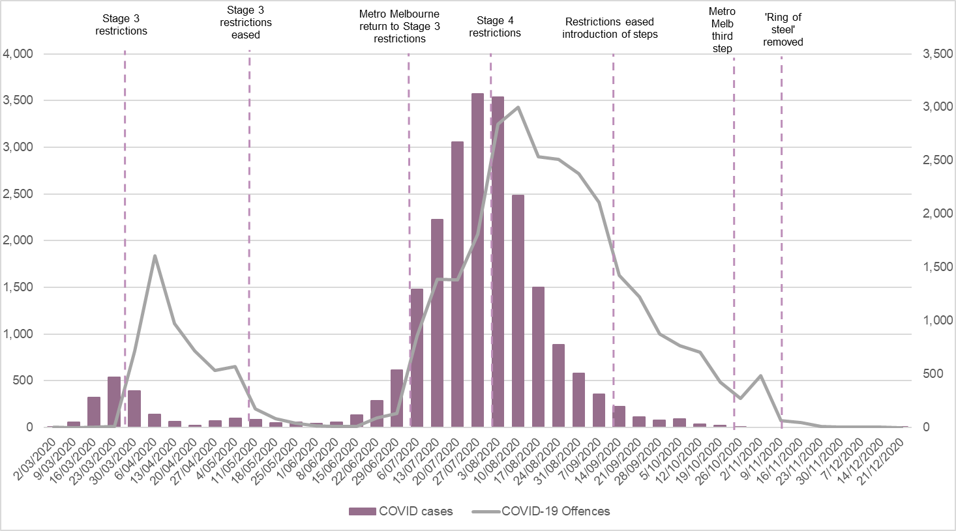
The increases in COVID-19-related offences seen in July and August (as shown in Figure 1 above) may also reflect the introduction of additional breach of CHO Directions offence types. For example, from 22 July face masks were made mandatory in Melbourne and Mitchell Shire and attracted a $200 fine.
3.2 Alleged offenders and CHO COVID-19-related offences
There were 26,531 unique offenders recorded for breaching COVID-19-related public health order restrictions between April and December 2020. This includes 34 businesses recorded for breaching COVID-19 restrictions during this period. Therefore, only a small number of Victorians received a COVID-19-related offence (or 0.5% of the population).
Table 2. Number of unique COVID-19 alleged offenders by principal police outcome, April to December 2020
Principal police outcome | n | %
Penalty infringement notice (fine) | 24,472 | 92.2
Not a penalty infringement notice | 2,509 | 8.0
- Arrest or Summons (Charges laid) | 1,344 | 5.1
- Caution/warning | 313 | 1.4
- All other outcomes¹ | 402 | 1.5
Total COVID-19 offenders | 26,531 | 100.0
Note: ¹ Includes intent to summons, not authorised, and other.
Table 2 above shows the most serious police action taken for each offender’s COVID-19-related offence. Most offenders (92%) received a PIN (fine). Only 5% of offenders were charged and approximately 1% received an official warning.
The following analysis relates to individual offenders (the 26,497 unique ‘COVID-19 offenders’) and excludes the 34 businesses. Three-quarters of COVID-19 offenders were male (74%, n=19,592) and one in four was female (26%, n=6,905). The average age of offenders at their first COVID breach was 31.4 years. Figure 2 below shows that offenders were more likely to be aged between 18 and 44 years, with 30% of offenders aged between 18 and 24 years (n=7,869), and 31% aged between 25 and 34 years (n=8,265).
Figure 2. Unique COVID-19 alleged offenders by age at first COVID-19 offence, April to December 2020
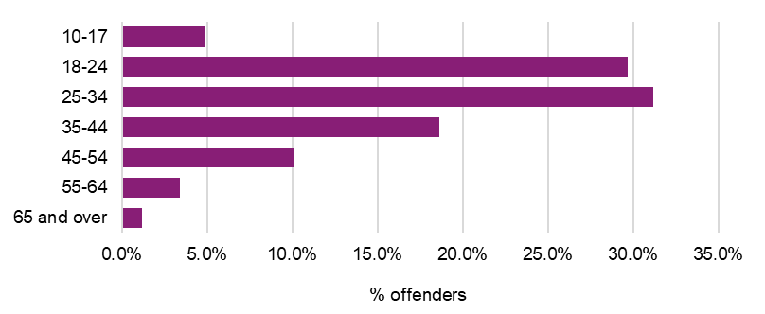
Table 3 below shows the number of COVID-19-related offences recorded for each unique offender between April and December 2020. While most offenders (78%) recorded only one COVID-19-related offence, one in five offenders were ‘repeat’ COVID-19 offenders: 13% recorded two offences and 4% recorded three. Just over 1% (n=378) of offenders recorded 6 or more offences.
Table 3. Number of COVID-19-related offences per unique COVID-19 alleged offender, April to December 2020
COVID-19 offences | n | %
1 | 20,747 | 78.3
2 | 3,485 | 13.2
3 | 1,177 | 4.4
4 | 458 | 1.7
5 | 252 | 1.0
6 or more | 378 | 1.4
Total COVID-19 offenders | 26,497 | 100.0
Two-thirds of COVID-19 offenders were recorded by police for other types of alleged criminal offences (either before or after the breach of COVID-19 restrictions; 64%, n=17,033). The remaining 36% represented COVID-19 only offenders (n=9,464). Figure 3 below shows the number of other criminal offences recorded prior to an individual’s first breach of a COVID-19 restriction offence for those with other criminal offences previously recorded. Nearly half of the offenders (48%) had recorded between one and 10 offences since July 2004, with 36% recording between 11 and 50 offences, and 16% more than 51 historical offences.

Figure 3. Number of offences each offender was recorded for prior to first breach of COVID-19-related offence

Figure 4 below illustrates the impacts of recording options on the COVID-19 PIN, country of birth was not recorded for the majority of ‘COVID only’ offenders (82% or 7,768) it was recorded for the majority of the ‘COVID and other’ offenders (92% or 15,623). Similarly, Aboriginal status was not recorded for 36% (n=3,386) of the ‘COVID only offenders’ compared with 0.8% (143) for ‘COVID and other’ offenders. Therefore, the following analysis are limited to the 17,033 ‘COVID and other’ offenders.
Figure 4. Unique alleged offender demographic recording rates, by COVID-19 offender group, April to December 2020
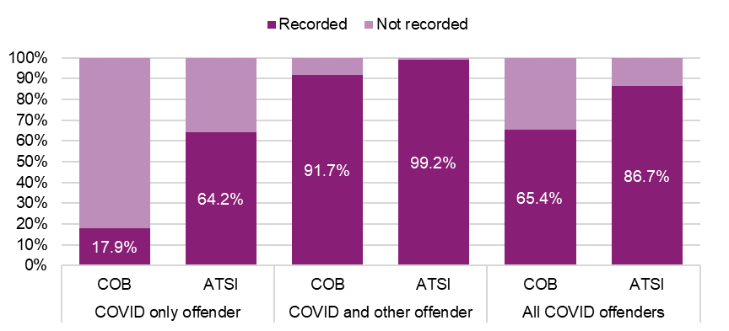
As shown below in Table 4, over two-thirds ‘COVID and other’ offenders (72%) were born in Australia. The second most common country of birth was Sudan or South Sudan (4%), this was followed by New Zealand (2%), Vietnam (1%), and India (1%).

Table 4. Unique COVID-19 only alleged offenders by country of birth, April to December 2020
Country of birth | n | %
1. Australia | 12,243 | 71.9%
2. Sudan and South Sudan | 610 | 3.6%
3. New Zealand | 394 | 2.3%
4. Vietnam | 176 | 1.0%
5. India | 156 | 0.9%
6. Afghanistan | 135 | 0.8%
7. UK & Ireland | 124 | 0.7%
8. Iran | 99 | 0.6%
9. Somalia | 99 | 0.6%
10. Iraq | 96 | 0.6%
All other countries | 1,491 | 8.8%
Unspecified | 1,410 | 8.3%
Total COVID-19 only offenders | 17,033 | 100.0%
Most ‘COVID and other’ offenders were not Aboriginal (94%, n=15,977), with 5% (n=913) of offenders identifying as Aboriginal (as shown below in Table 5).
Table 5. Unique COVID-19 and other alleged offenders by principal police outcome and Aboriginal status, April to December 2020
Principal police outcome | Aboriginal | Not Aboriginal | Total COVID and other offenders¹
Penalty infringement notice (fine) | 849 (93.0%) | 14,842 (92.9%) | 15,812 (92.8%)
Not a penalty infringement notice | 64 (7.0%) | 1,135 (7.1%) | 1,221 (7.2%)
- Arrest or Summons (Charges laid) | 55 (6.0%) | 880 (5.5%) | 951 (5.6%)
- Caution/warning | 4 (0.4%) | 105 (0.7%) | 111 (0.7%)
- All other outcomes² | 5 (0.5%) | 150 (0.9%) | 159 (0.9%)
Total COVID and other offenders | 913 (100.0%) | 15,977 (100.0%) | 17,033 (100.0%)
Note: ¹ Includes unknown Aboriginal status.
Note: ² Includes intent to summons and not authorised.
Due to the limitations of the data, it remains unclear if these groups of people (for example, those who identify as Aboriginal or from Sudan or South Sudan) are overrepresented in COVID-19-related offences as the data are based on those with other criminal offending recorded. Therefore, it reflects the wider criminal justice population (Department of Justice and Community Safety, 2020a; 2020b) or those recorded for a range of different offences, rather than the characteristics of COVID-19 offenders specifically.

3.3 COVID-19-related recorded crime trends
Figure 5 below compares the number of offences reported to Victoria Police per week throughout 2019 and 2020. This figure excludes new offences introduced as part of the COVID-19 restrictions (as discussed in Section 3.1 and 3.2). Overall, 497,704 offences were reported in 2020. This represents an 8% decrease from the previous year when 538,454 offences were reported to police.
Figure 5. Number of offences reported to police by week, January 2019 to December 2020
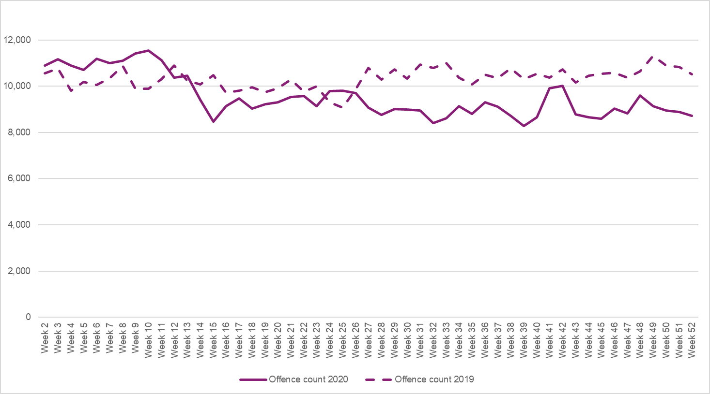
As shown above, the number of crimes reported to police was trending higher at the start of 2020 (compared to 2019) until a week prior to the introduction of COVID-19 restrictions (Week 12, March), dropping further in early April (Week 15). There were two more decreases associated with the introduction of more stringent CHO directions and restrictions to support public health responses (Week 32, August and Week 39, September) and an increase following the easing of these restrictions (Week 41 and 42, October). This trend suggests crimes reported to police were unsurprisingly impacted by restrictions (such as decreased mobility). However, these impacts are smoothed over the COVID-19 disrupted period, suggesting that community judgments about increased risk of COVID-19 transmission also had an impact, particularly as case numbers started to rise. This is emphasised by Figure 6 below, which displays the offences committed each week overlaid with Victorian COVID-19 case numbers. Whilst there are some fluctuations following some of the stages where restrictions were implemented (notably in April and August), there was an overall stable, tending to decrease, throughout the whole period.

Figure 6. Number of offences by week and COVID-19 cases, committed 6 January to 29 November 2020
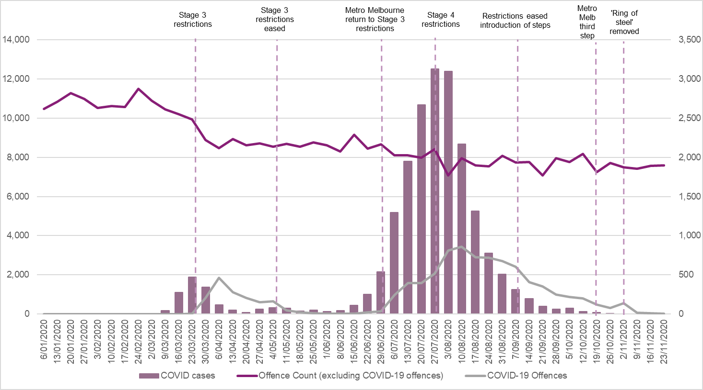
An overview of the number of offences (by CSA offence division) committed each week between January and November 2020 is provided in Figure 7 (excluding COVID-19-related offences). This figure does not include December due to the potential for a recording lag when using the date the offence was committed (as discussed in Section 2). This figure shows that ‘Property and deception’ offences were most impacted by COVID-19 restrictions, experiencing the largest decrease of all offence types.
Figure 7. Number of offences committed by week and COVID-19 cases, 6 January to 29 November 2020
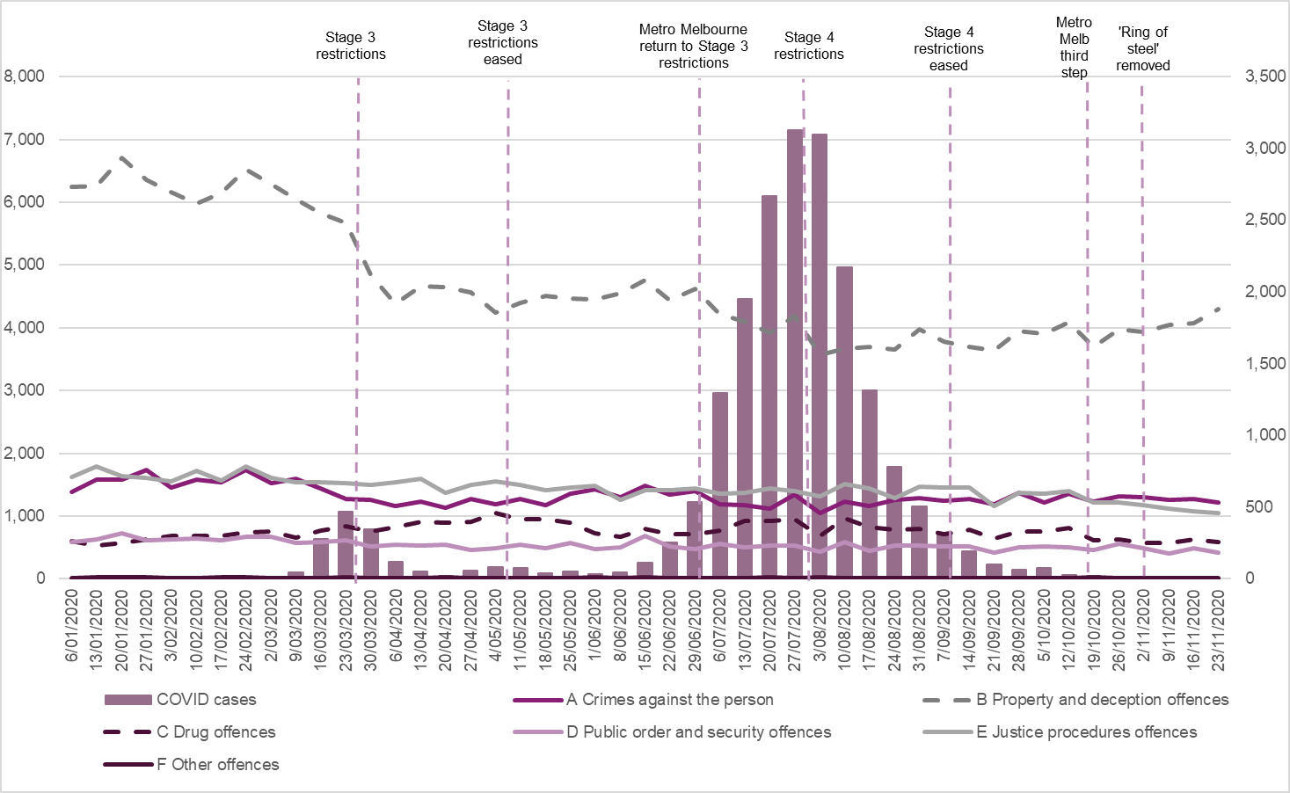
The following section discusses offence types that may have been impacted in by the pandemic. These data are available on the webpage accompanying this paper or in the Latest Victorian crime data Recorded offences section.
Property and deception offences
‘Property and deception’ offences decreased from 305,100 offences created in 2019 to 268,136 in 2020 (representing a 12% decrease). This reflected reductions in burglary/break and enter offences (21%) and theft offences (14%). The large drop in property-related offences, especially acquisitive offences relating to theft suggests that restrictions, particularly people staying home/within their 5kms radius, and the closing of all non-essential retail stores (Stage 4), reduced the opportunity to commit these crimes. As shown in Figure 7, while the easing of restrictions did not result in an immediate increase to pre-pandemic levels, by November 2020 offending was again trending upwards. Therefore, other factors may have also contributed to decreases, such as community concern around COVID-19 cases impacting upon people’s decisions about their own activities regardless of restrictions and increases to welfare payments.
Crimes against the person
Overall, ‘Crimes against the person’ offences do not appear to have been substantially impacted by the pandemic and associated restrictions (with 82,473 offences created in 2019, and 84,477 in 2020). There were however trends of note in robbery offences as well as serious and common assaults.
Figure 8. Serious and common assault offences (excluding FV) committed by week and COVID-19 cases, 6 January to 29 November 2020
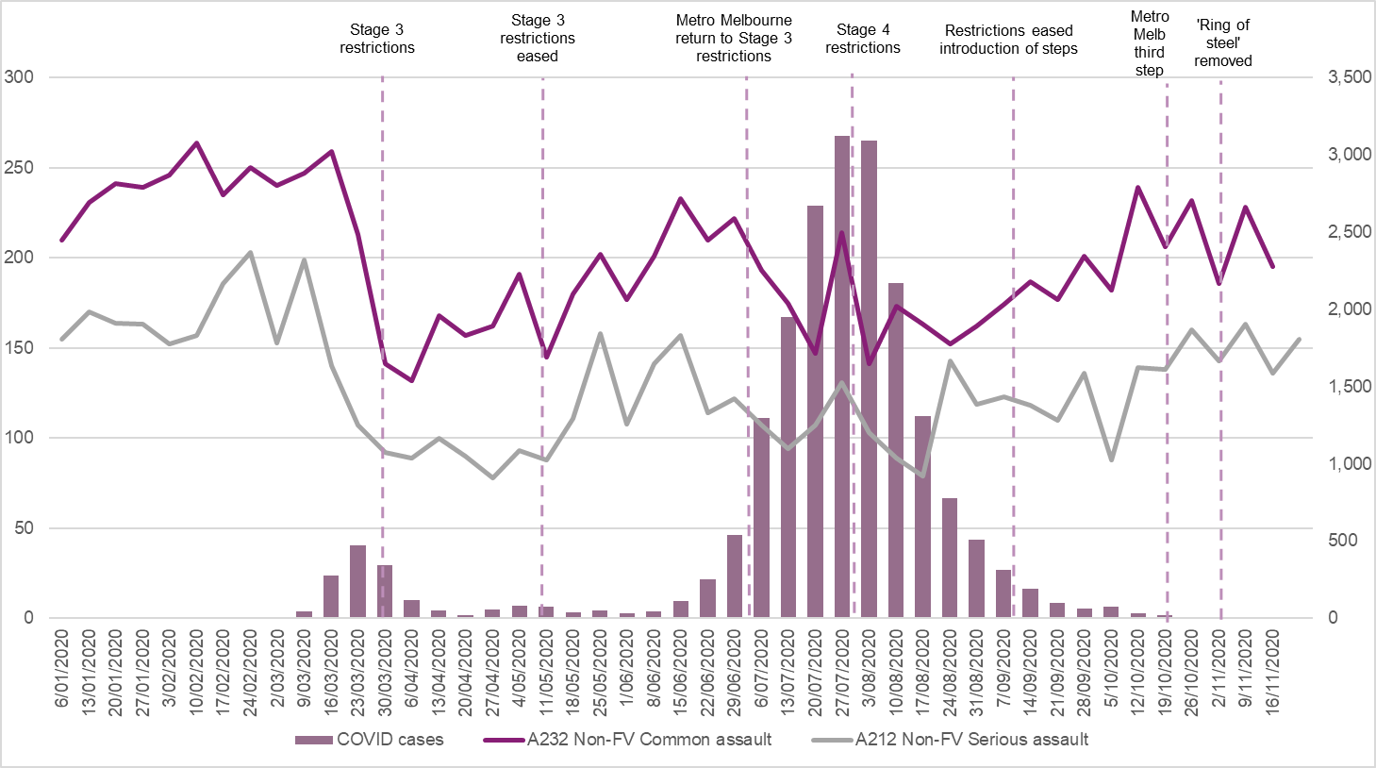
While common assaults increased by 2%, serious assault decreased by 7% compared to the year prior. However, when excluding FV related offences both non-FV serious and common assaults decreased in the last 12 months (by 10% and 4% respectively). Figure 8 shows when assaults were allegedly committed (excluding FV assaults) mapped against COVID-19 cases. There was a sharp decrease during the introduction of Stage 3 and 4 restrictions. Furthermore, by the end of 2020, the number of assaults committed had not returned to pre-pandemic levels.
In contrast, a different pattern was observed for common and serious assaults associated with FV incidents. In the last 12 months there was a decrease in serious assaults (4%) but an increase in common assaults (7%) related to FV. Unlike assaults that are more likely to occur in the public spaces (non-FV assaults), there was not the same decrease in opportunity for FV-related assaults. This likely related to an exacerbation of stressors during COVID-19 (as noted in Piquero et al., 2021). FV incidents are further explored in the upcoming Section 3.4.
In line with the drop in property offences, the number of robberies dropped substantially during the last 12 months (29%). In 2019, there were 4,034 robbery offences created, reducing to 2,878 in 2020. Figure 9 below shows when robberies were allegedly committed mapped against COVID-19 cases.
Figure 9. Robbery offences committed by week and COVID-19 cases, 6 January to 29 November 2020
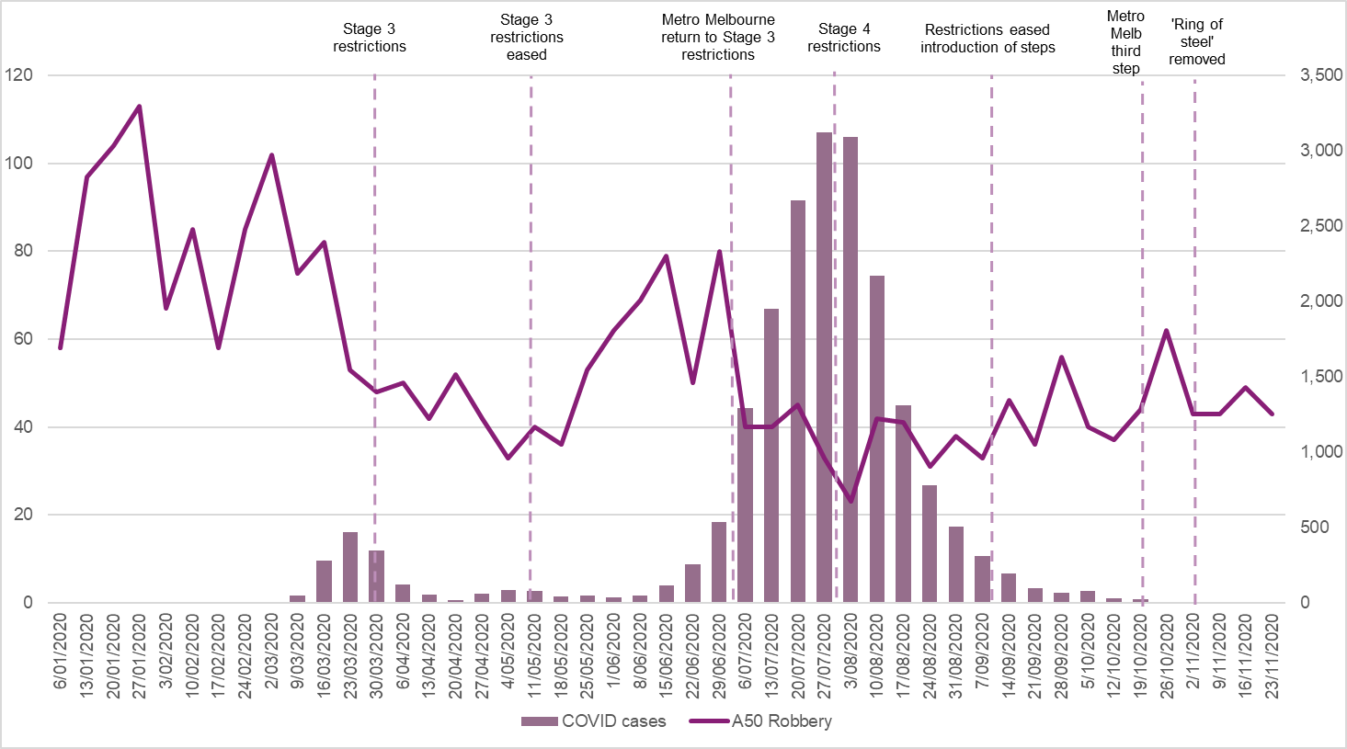
The figure above shows substantial reductions in robbery offences committed prior to the introduction of Stage 3 restrictions in March (possibly related to community concern around COVID-19 and the resulting changes in behaviour due to health advice and media reporting as formal public health orders were yet to be implemented). There were also small reductions seen in the re-introduction of Stage 3 and the move to Stage 4. Interestingly, Figure 9 shows that the increase following the first easing of restrictions (in May/June) was not replicated at the end of 2020 as restrictions eased again. This may suggest a level of continued behaviour modification despite the removal of formal orders (for example, continuation of people working from home resulting in reduced access to victims).
Drug offences
Unlike other types of crime, ‘Drug offences’ increased substantially (by 20%) in the last 12 months (increasing to 40,575 offences created on the system in 2020, from 33,734 offences in 2019). This was linked to increases in the following subcategories: cultivate or manufacture drugs (29%), drug use and possession (21%), and drug dealing and trafficking (12%). Unlike the previous offences discussed, this is a detectable crime, whereby reductions in high volume crimes, such as ‘Property and deception’ offences, may have resulted in the redirection of police resources to pursue and uncover these crimes.
Figure 10 shows the weekly commit date data for two drug offence categories mapped against the COVID-19 cases. As shown in this figure, a discernible trend was observed in drug use and possession offences. Particularly, there was a sharp increase in drug use and possession offences following the introduction of Stage 3 restrictions, and a small decline and later increase following the introduction of Stage 4. This may provide evidence for the use/possession of drugs as a coping strategy, but it may also be the case that the mobility restrictions made drug offenders easier for police to detect without the usual camouflage of the rest of the population. Increased police powers in enforcing CHO directions may have provided police with the opportunity to search people who were breaking restrictions (for example, out past curfew), potentially leading to increased detection of drugs.
Figure 10. Drug related offences committed by week and COVID-19 cases, 6 January to 29 November 2020
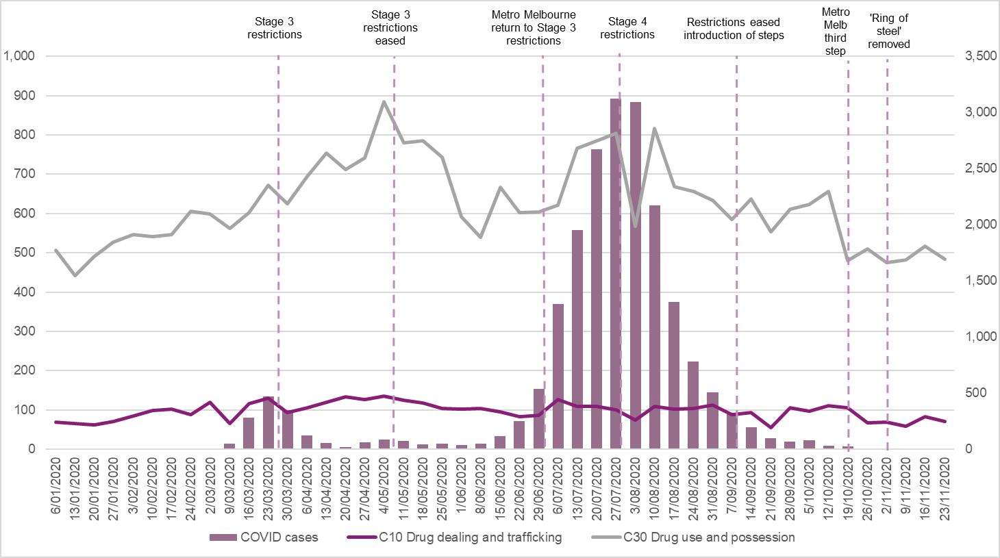
3.4 Family violence incidents
Victoria Police recorded 92,521 family incidents in 2020, a 9% increase (up by 7,978 incidents) compared to 2019. Figure 11 below depicts weekly numbers of family incidents recorded between January and December 2020.
As shown in the below figure, the introduction and easing of restrictions had some impact on the number of FV incidents. There was a small reduction in incidents when Stage 3 restrictions were introduced (March and late June/early July), and an increase when they were eased (May/early June). This pattern changes with the introduction of Stage 4 restrictions (July) which resulted in an increase in the number of incidents being recorded. This continued for the remainder of 2020, with spikes also seen October and November. Figure 11 therefore may provide some evidence that the severity of restrictions impacted trends across the year.

Figure 11. FV incidents and COVID-19 cases by week, created January to December 2020
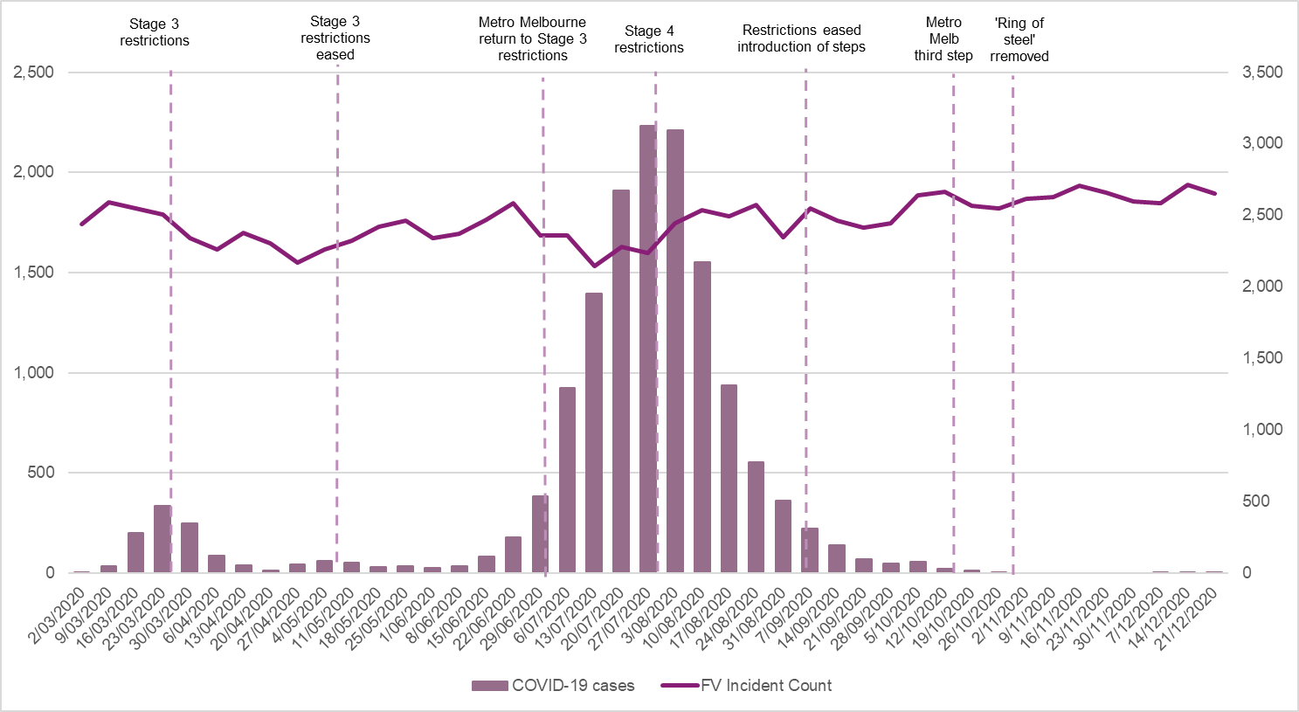
This is supported by differences in the number of FV incidents recorded in metropolitan and regional locations. Metropolitan Melbourne saw a 10% increase in the number of FV incidents reported in 2020, compared to the year prior (60,583 incidents compared to 55,080). In comparison, regional Victoria experienced a more modest increase (8%, 31,715 incidents compared to 29,338). Table 6 below shows the percentage change in the number of FV incidents reported between 2019 and 2020.
Table 6. Percentage change in FV incidents by region and month, 2019 and 2020
Month | Metropolitan Melbourne | Regional Victoria
January | 5.3% | -3.7%
February | 8.6% | 4.3%
March | 12.4% | 4.8%
April | 7.8% | 3.4%
May | 17.3% | 5.8%
June | 19.4% | 7.8%
July | 4.3% | 5.6%
August | 14.3% | 12.4%
September | 8.2% | 8.3%
October | 14.0% | 19.6%
November | 9.8% | 21.0%
December | 1.3% | 9.8%
Overall | 10.0% | 8.1%
As per the above table, metropolitan Melbourne experienced spikes in the number of FV incidents in March, May, June, August, and October. This corresponds to the introduction and easing of restrictions. In contrast, regional Victoria saw spikes in the latter half of the year (August, October, and November). This is a surprising finding for two reasons: 1. regional Victoria did not experience Stage 4 restrictions (the severest category) and 2. by the end of the year, restrictions had eased across the state (as per Table 1). Therefore, while Table 6 provides further evidence that restrictions impacted trends, it also suggests another mechanism might be at play (rather than COVID-19 restrictions alone). CSA will continue to monitor these trends over time.
Forecasting models were developed to further test the potential impacts of the pandemic on the number of family incidents (Figure 12). As shown in the figure below, the numbers of incidents in June and August were higher than forecasted for FV incidents (overall) but remained within the prediction intervals for other months. The overall average number of family incidents (7,647.6) was 5% higher than the average forecasted number (7,305.7).
Figure 12. Forecast on the number of family incidents for April to December 2020
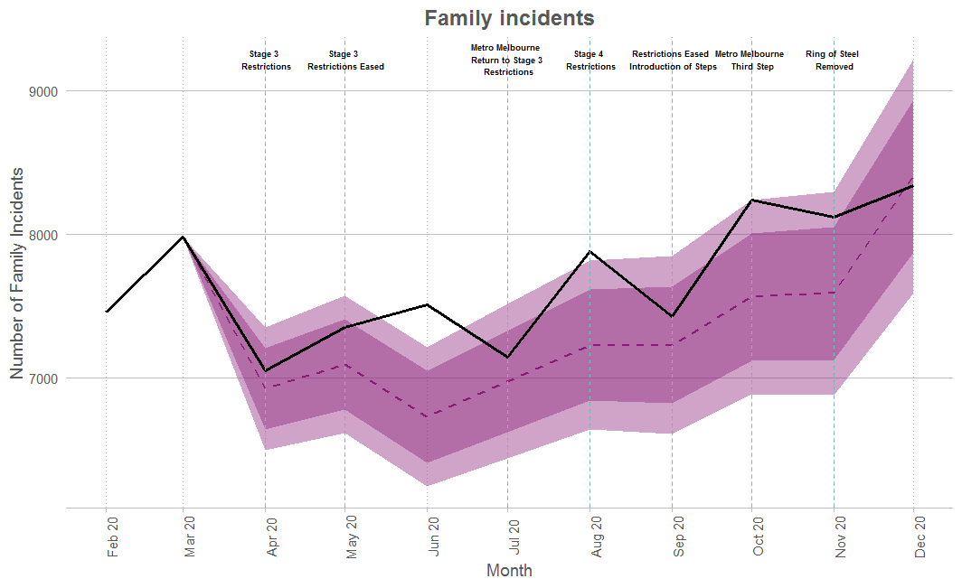 | 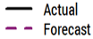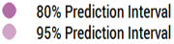
The number of AFMs recorded by their relationship type to the perpetrator was examined (Figure 13). These models provide estimates for the period of April to December 2020, based on historical data from January 2012 to March 2020.
In June the number recorded for current partner and parent/child relationships was higher than forecasted. Those involving former partners were lower than expected, particularly in April, July, and September (the former two months were when restrictions were in place, and the latter is when restrictions were easing). This might suggest that the restrictions impacted a perpetrator’s ability to contact the victim, particularly if they did not live with each other (for example, the reduction in mobility due to 5km restrictions). The average monthly actual and forecast number of by relationship type are provided below in Table 7.

Figure 13. Forecast on the number of AFMs by relationship type, April to December 2020
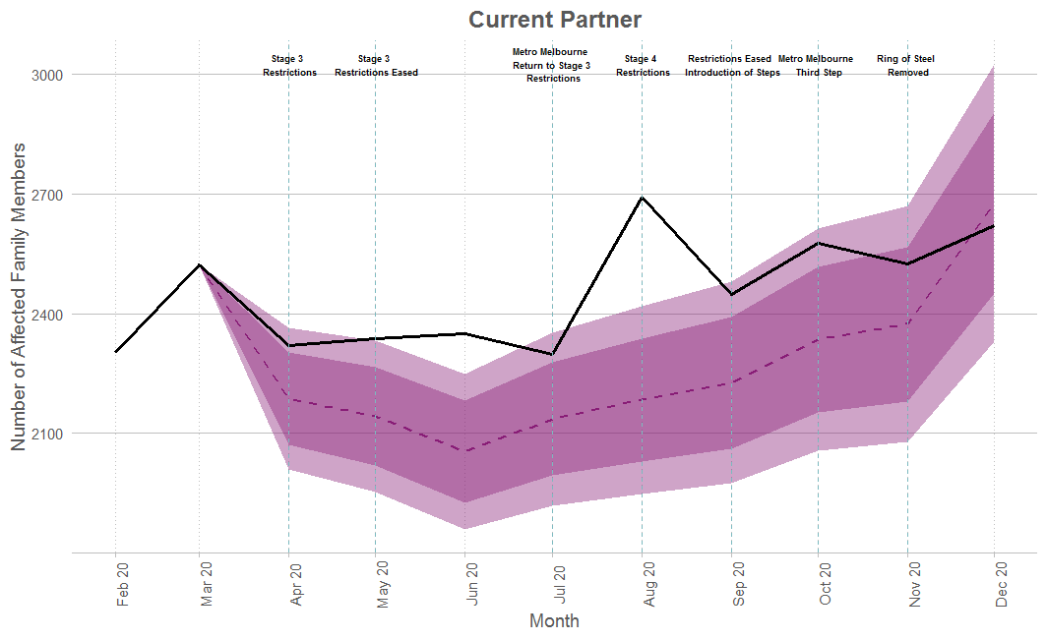 | 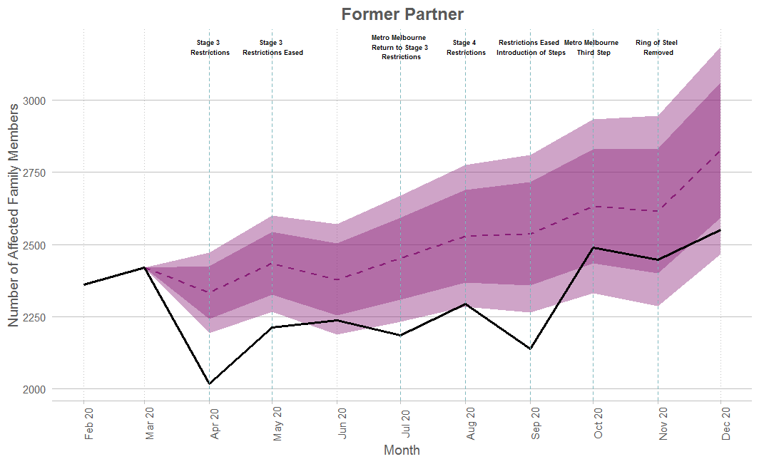
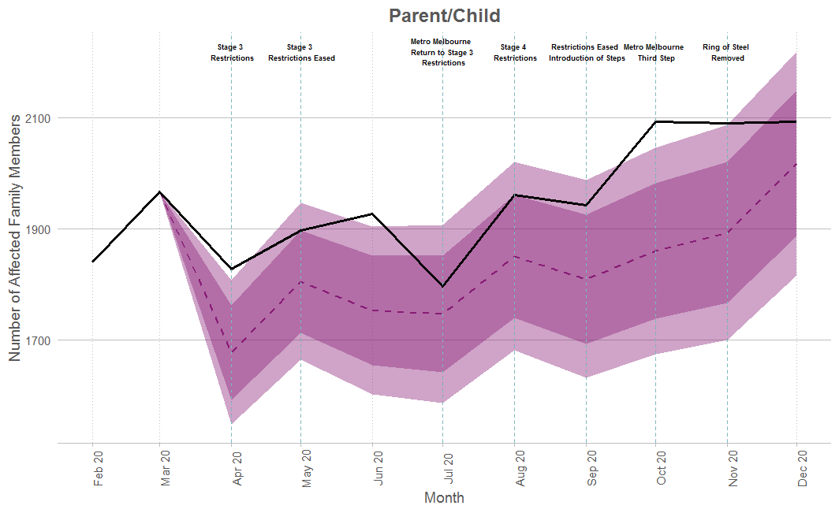
As shown in the below, the actual average per month was higher for two out of the three relationship types. Current partner showed the highest difference (8%), followed by parent/child (7%). In contrast, actual average incidents involving former partners were 11% lower than the forecasted average.
Table 7. Average number, actual and forecast, of AFMs by relationship type, April to December 2020
 | Average per month (April to December 2020)
Relationship type | Actual | Forecast | % difference  (forecast vs actual)
Current Partner | 2,463.2 | 2,257.6 | -8%
Former Partner | 2,286.3 | 2,526.5 | 11%
Parent/Child | 1,959.0 | 1,824.4 | -7%

Figure 14 compares the number of AFMs by relationship to the perpetrator from June to December 2020 to the year prior. This period was chosen for comparison due to a change in recording practices, with parent and child relationship options combined prior to June 2019. During this period 17,510 current partner relationships were recorded (up 10% compared with the same period in 2019), 16,346 involved former partners (up by 10%), 9,320 involved parents (up by 14%) and 4,585 involved children (including adult children) of the perpetrator (up by 14%).

Figure 14. AFMs by type of relationship to other party, June to December 2019 and 2020
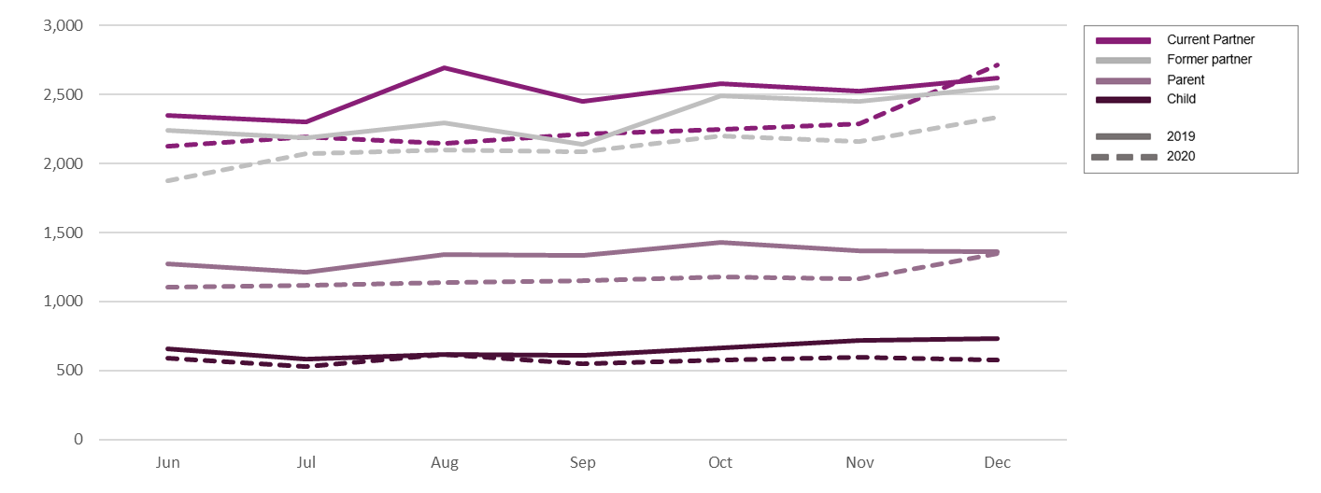
The number of AFMs in 2020 was higher across all relationship types suggesting again that the pandemic and associated restrictions had an impact. However, it could also be reflective of proactive policing during 2020 where Victoria Police targeted known FV perpetrators (known as Operation Ribbon), which may have led to police detecting more incidents or provided victims with more opportunity to report incidents to them.
- Discussion
The COVID-19 pandemic had a significant impact on the daily life of Victorians in 2020. This included restrictions on movements and daily activities, working or studying from home where possible and periods of temporary closures of some non-essential businesses. This study used Victoria Police recorded crime data from 2020 to examine trends for offences for breaches of CHO restrictions (specific COVID-19-related public health offences), other criminal offences, and FV incidents. This built on the previous CSA analyses released last year.
This study found that disruptions to daily life during this period had a flow on effect on recorded crime. Impacts were more pronounced during the periods of restriction with the highest case numbers. This is in line with international literature (Campedelli et al., 2020; Cheung and Gunby, 2021; Kim and Leung, 2020; Sun et al., 2021). This study identified that:
- A small number of Victorians received a COVID-19-related offence (0.5%). In total, there were 26,497 individuals who breached the CHO directions (typically during the height of the Victorian ‘second wave’ of COVID-19 cases). This might suggest a relatively high community compliance rate and/or police discretion.
- The pandemic and resulting restrictions impacted crime types differently. There was a substantial decrease in property and deception offences (12%) such as burglary/break and enter and theft. This replicates what has been observed in other criminal justice jurisdictions (Campedelli et al., 2020; Cheung and Gunby, 2021; FBI National Press Office, 2021; Kim and Leung, 2020; Sun et al., 2021). There was a modest increase in crimes against the person (2%) with trends of note in serious and common assaults. There was a reduction in non-FV common and serious assaults. However, there was an increase in FV common assaults and a decrease in FV serious assault. This finding may explain why Payne et al. (2020) found that the rates of common assault, while lower during Queensland’s restrictions, were not statistically significantly different from the preceding periods, but serious assault was. Their analysis did not separate assault that occurs within the FV context. In contrast, drug offences increased substantially (by 20%), perhaps providing evidence for the use/possession of drugs as a coping strategy (for example, a self-medicating or to combat boredom) (Anderson and Hodgkinson, 2020; Dietze and Peacock, 2020; Office for National Statistics, 2020). However, it may also suggest that restrictions resulted in the redirection of police resources to pursue these crimes and/or made detection of drug offenders easier.
- FV incidents increased during the pandemic (by 9% overall). This reflects US based research which showed similar increases (Piquero et al., 2021) as well as Victorian practitioner views (Pfitzner et al., 2020). The trends for FV incidents changed as restrictions were introduced (a reduction in reporting after Stage 3), became stricter (an increase in reporting as Stage 4 restrictions began), or eased (an increase in reporting). These trends suggest that the easing as well as the severity of restrictions may be associated with increased willingness of victims to report incidents to the police. However, trends in FV during this period may also have been driven through proactive FV policing through Victoria Police’s Operation Ribbon.
- The restrictions also impacted the relationship of affected family members to other parties, with monthly averages for former partners lower than the forecasts but higher than forecast for current partners. This might suggest that during movement restrictions and lockdowns, cohabitation increases risk of violence.
- Metropolitan Melbourne also experienced a higher volume increase in FV incidents compared to regional Victoria, possibly providing further evidence that more intensive restrictions (Stage 4) had a greater impact on crime trends.
The Victorian experience of the pandemic and the resulting restrictions provided a unique opportunity to examine crime trends over the course of almost a year, with different levels of restrictions in place across that year. As at the end of December 2020, crime trends had not returned to pre-pandemic levels. While there was not a sharp increase in crime as restrictions were eased, some crimes did show an upward trend in this period (for example, property and deception offences). This represents a unique opportunity to continue to monitor these trends over time as restrictions continue to lift and daily routines of Victorians start to return to a more pre-pandemic state.

References
Andersen, M. and Hodgkinson, T. (2020). Somehow I always end up alone: COVID-19, social isolation and crime in Queensland, Australia. Crime Science, 9, article no. 25.

Ashby, M. (2020). Initial evidence on the relationship between the coronavirus pandemic and crime in the United States. Crime Science, 9, article no. 6.

Boxall, H., Morgan, A. and Brown, R. (2020). The prevalence of domestic violence among women during the COVID-19 pandemic. Statistical Bulletin no. 28. Canberra: Australian Institute of Criminology.

Campedelli, G., Aziani, A. and Favarin, S. (2020). Exploring the immediate effects of COVID-19 containment policies on crime: An empirical analysis of the short-term aftermath in Los Angeles. American Journal of Criminal Justice, DOI: https://doi.org/10.1007/s12103-020-09578-6

Cheung, L. and Gunby, P. (2021). Crime and mobility during COVID-19 lockdown: A preliminary empirical exploration. New Zealand Economic Papers, DOI: https://doi.org/10.1080/00779954.2020.1870535

Crime Statistics Agency (2015). Offence Classification. Melbourne: Crime Statistics Agency. Available online at: https://www.crimestatistics.vic.gov.au/about-the-data/classifications-and-victorian-map-boundaries/offence-classification

Department of Justice and Community Safety. (2020a). Annual prisoner statistical profile 2009-10 to 2019-20. Melbourne: Corrections Victoria. Available at: https://www.corrections.vic.gov.au/annual-prisoner-statistical-profile-2009-10-to-2019-20

Department of Justice and Community Safety. (2020b). Annual offender statistical profile 2010 to 2020. Melbourne: Corrections Victoria. Available at: https://www.corrections.vic.gov.au/annual-offender-statistical-profile-2010-to-2020

Department of Health and Human Services (2021). Victorian Coronavirus (COVID 19) data. Available at: https://www.dhhs.vic.gov.au/victorian-coronavirus-covid-19-data, downloaded on 17 Feb 2021.

Dietze, P. and Peacock, A. (2020). Illicit drug use and harms in Australia in the context of COVID‐19 and associated restrictions: Anticipated consequences and initial responses. Drug and Alcohol Review, 39(4). DOI: https://doi.org/10.1111/dar.13079.

Freeman, K. (2020). Has domestic violence increased in NSW in the wake of COVID-19 social distancing and isolation? Update to April 2020. Crime and Justice Statistics Bureau Brief no. 146. Sydney: Bureau of Crime Statistics and Research.

FBI National Press Office (2020). Overview of Preliminary Uniform Crime Report, January-June, 2020. Washington, D.C: Federal Bureau of Investigation. Available online at: https://www.fbi.gov/news/pressrel/press-releases/overview-of-preliminary-uniform-crime-report-january-june-2020.

Gare, S., Bright, S., Barnaba, L., Phillips, B. and Millsteed, M. (2020). Police-recorded crime trends in Victoria during the COVID-19 pandemic: update to the end of September. In Brief no. 11. Melbourne: Crime Statistics Agency.

Kim, M. and Leung, F. (2020) COVID-19 pandemic and crime trends in NSW. Crime and Justice Statistics Bureau Brief no. 147. Sydney: Bureau of Crime Statistics and Research.

Nix, J. and Richards, T. (2021) The immediate and longer-term effects of COVID-19 stay-at-home orders on domestic violence calls for service across six U.S. jurisdictions. Police Practice and Research, DOI: https://doi.org/10.1080/15614263.2021.1883018.

Office for National Statistics (2020). Coronavirus and crime in England and Wales: August 2020. London: Office for National Statistics.
Payne, J., Morgan, A. and Piquero, A. (2020). COVID-19 and social distancing measures in Queensland, Australia, are associated with short-term decreases in recorded violent crime. Journal of Experimental Criminology, DOI: https://doi.org/10.1007/s11292-020-09441-y
Pfitzner, N., Fitz-Gibbon, K. and True, J. (2020). Responding to the ‘shadow pandemic’: practitioner views on the nature of and responses to violence against women in Victoria, Australia during the COVID-19 restrictions. Melbourne: Monash University. Available online at: https://doi.org/10.26180/5ed9d5198497c.
Piquero, A., Jennings, W., Jemison, E., Kaukinen, C. and Knaul, F. (2021). Domestic violence during COVID-19: Evidence from a systematic review and meta-analysis. United States: Council on Criminal Justice, National Commission on COVID-19 and Criminal Justice. Available online at: https://cdn.ymaws.com/counciloncj.org/resource/resmgr/covid_commission/Domestic_Violence_During_COV.pdf
Piquero, A., Riddell, J., Bishopp, S., Narvey, C., Reid, J. and Piquero, N. (2020) Staying home, staying safe? A short-term analysis of COVID-19 on Dallas domestic violence. American Journal of Criminal Justice, DOI: https://doi.org/10.1007/s12103-020-09531-7.
Rmandic, S., Walker, S., Bright, S. and Millsteed, M. (2020). Police-recorded crime trends in Victoria during the COVID-19 pandemic. In Brief no. 10. Melbourne: Crime Statistics Agency.

State Government of Victoria (2020). Fines, enforcement, and reporting. Available online at: https://www.coronavirus.vic.gov.au/fines-enforcement-and-reporting
Stickle, B. and Felson, M. (2020). Crime rates in a pandemic: The largest criminological experiment in history. American Journal of Criminal Justice, 45(4), 525-536.
Sun, Y., Huang, Y., Yuan, K., Chan, T. and Wang, Y. (2021) Spatial patterns of COVID-19 incidence in relation to crime rate across London. International Journal of Geo-Information, DOI: https://doi.org/10.3390/ijgi10020053
Victoria Police (2019). Code of practice for the investigation of family violence (3rd edition). Melbourne: Victoria Police.

From 8 July to 28 October 2020.
This paper is primarily concerned with the impact of restrictions on the movement of people and associated alleged criminal offending. As such, restrictions around remote learning, childcare and other specific industries have not been included in the list above despite their significant impact on Victorians throughout the second wave. For comprehensive details of all restrictions and easing see www.coronavirus.vic.gov.au
For example, fines are in force in England and Wales (see: https://www.bbc.com/news/uk-england-55634869), New Zealand (see: https://www.stuff.co.nz/national/health/coronavirus/124391697/covid19-police-yet-to-issue-any-fines-to-people-not-wearing-face-masks), Canada (see: https://www.ctvnews.ca/health/coronavirus/millions-of-dollars-in-covid-19-fines-disproportionately-hurting-black-indigenous-marginalized-groups-report-1.4999052), and parts of Europe (see: https://www.wsj.com/articles/as-covid-19-roars-back-in-europe-governments-get-tougher-on-rule-breakers-11603111859). While some countries, such as Japan, have only recently introduced fines in 2021 (https://www.timeout.com/tokyo/news/japan-to-introduce-fines-penalising-those-breaking-covid-19-safety-measures-020221).
Often data is not collected in a uniform manor, requiring cleaning prior to analysis. Therefore, difficulties arise when comparing across jurisdictions (Nix and Richards, 2021).
Often focused on the early weeks of the restrictions (or early 2020).
Restrictions differ within and between jurisdictions and changed over the course of 2020 (and the resulting infection ‘waves’). Therefore, the impact may change over time as restrictions are introduced and later lifted
This period captures the first and the beginning of the second round of restrictions (also known as ‘first’ and ‘second’ lockdowns).
Based on forecasts developed using historical data.
The 16 large cities or urban counties in the United States included: Austin, Baltimore, Boston, Chicago, Dallas, Los Angeles, Louisville, Memphis, Minneapolis, Montgomery County, Nashville, Philadelphia, Phoenix, San Francisco, Tucson, and Washington.
Excluding family violence serious and common assaults.
Which provides 24-hour assistance for victims.
This data reports state-wide monthly offence rates (per 100,000).
When the stay at home orders were in place.
https://www.theage.com.au/national/victoria/closed-doors-won-t-protect-you-police-ramp-up-response-to-family-violence-20200421-p54lqx.html
The six US jurisdictions included: New Orleans, Cincinnati, Seattle, Salt Lake City, Montgomery County, and Phoenix.
A small number of COVID 19 offences were committed prior to March (≤5). The data in Figure 1, was based on ‘commit’ rather than ‘create’ date.
Source for Victorian COVID-19 case numbers DHHS data https://www.dhhs.vic.gov.au/victorian-coronavirus-covid-19-data, downloaded on 17 Feb 2021.
Based on population data used by CSA (taking into account age of criminal responsibility), see https://www.crimestatistics.vic.gov.au/about-the-data/explanatory-notes.
This number is based on report date and excludes COVID-19 offences. When create date is used, and COVID-19 offences are included, there is a modest 2% increase in offences in 2020 (there was 535,952 offences reported in 2019, increasing to 548,354 offences in 2020).
Source for Victorian COVID-19 case numbers DHHS data https://www.dhhs.vic.gov.au/victorian-coronavirus-covid-19-data, downloaded on 17 Feb 2021.
Ibid.
https://www.abc.net.au/news/2021-02-23/jobseeker-welfare-unemployment-payment-changes-explained/13183556
Source for Victorian COVID-19 case numbers DHHS data https://www.dhhs.vic.gov.au/victorian-coronavirus-covid-19-data, downloaded on 17 Feb 2021.
Source for Victorian COVID-19 case numbers DHHS data https://www.dhhs.vic.gov.au/victorian-coronavirus-covid-19-data, downloaded on 17 Feb 2021.
Source for Victorian COVID-19 case numbers DHHS data https://www.dhhs.vic.gov.au/victorian-coronavirus-covid-19-data, downloaded on 17 Feb 2021.
Source for Victorian COVID-19 case numbers DHHS data https://www.dhhs.vic.gov.au/victorian-coronavirus-covid-19-data, downloaded on 17 Feb 2021.
January to December 2019 and 2020.

