Crime Statistics Victoria
Year ending 31 March 2021

Unless indicated otherwise, content in this publication is provided under a Creative Commons Attribution 4.0 International Licence. To view a copy of this licence, visit creativecommons.org/licenses/by/4.0. It is a condition of the Creative Commons Attribution 4.0 International Licence that you must give credit to the original author who is the Crime Statistics Agency.
If you would like to receive this publication in an accessible format, such as large print or audio, please telephone Crime Statistics Agency on 03 8684 1808 or email info@crimestatistics.vic.gov.au.
For further information or additional copies, please contact:
Crime Statistics Agency
121 Exhibition Street, Melbourne, VIC 3000
Tel 03 8684 1808

Contents
1. Recorded criminal incidents 3
2. Recorded offences 4
3. Alleged offender incidents 6
4. Victim reports 8
5. Family incidents 9
6. Alleged offender incidents by Aboriginal and Torres Strait Islander status 11
7. Family incidents by Aboriginal and Torres Strait Islander status 13

1. Recorded criminal incidents
A recorded criminal incident is a criminal event that may include multiple offences, alleged offenders and/or victims that is recorded on the LEAP database on a single date and at one location. For more information about counting rules, please refer to the Explanatory Notes.
Since early 2020 Victoria has been responding to the global COVID-19 pandemic through a range of health responses that have included periods of restrictions on people’s movements and daily activities. The health response was supported by the introduction of new COVID-19-related offences codes relating to breaches of Chief Health Officer (CHO) Directions the Public Health and Wellbeing Act 2008. The restrictions on movement and introduction of breaches of CHO directions had a flow on effect for Victorian recorded crime, and this differed by crime type. For more information about the impacts of COVID-19 on crime please see the CSA paper Police-recorded crime trends in Victoria during the COVID-19 pandemic: update to the end of December 2020.
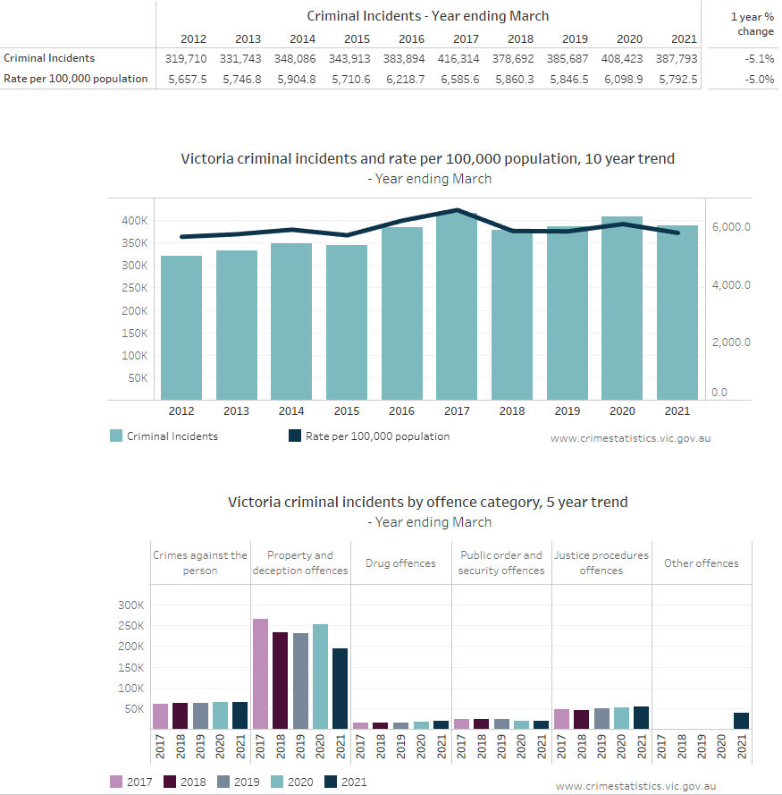

Please note that movements in recorded crime data may be impacted by changes in legislation and operational police practice. Information is available about notable changes in the Explanatory Notes, refer to this information when comparing data over time.

2. Recorded offences
Recorded offences include any criminal act or omission by a person or organisation for which a penalty could be imposed by the Victorian legal system. For more information about counting rules, please refer to the Explanatory Notes.
Since early 2020 Victoria has been responding to the global COVID-19 pandemic through a range of health responses that have included periods of restrictions on people’s movements and daily activities. The health response was supported by the introduction of new COVID-19-related offences codes relating to breaches of Chief Health Officer (CHO) Directions the Public Health and Wellbeing Act 2008. The restrictions on movement and introduction of breaches of CHO directions had a flow on effect for Victorian recorded crime, and this differed by crime type. For more information about the impacts of COVID-19 on crime please see the CSA paper Police-recorded crime trends in Victoria during the COVID-19 pandemic: update to the end of December 2020.
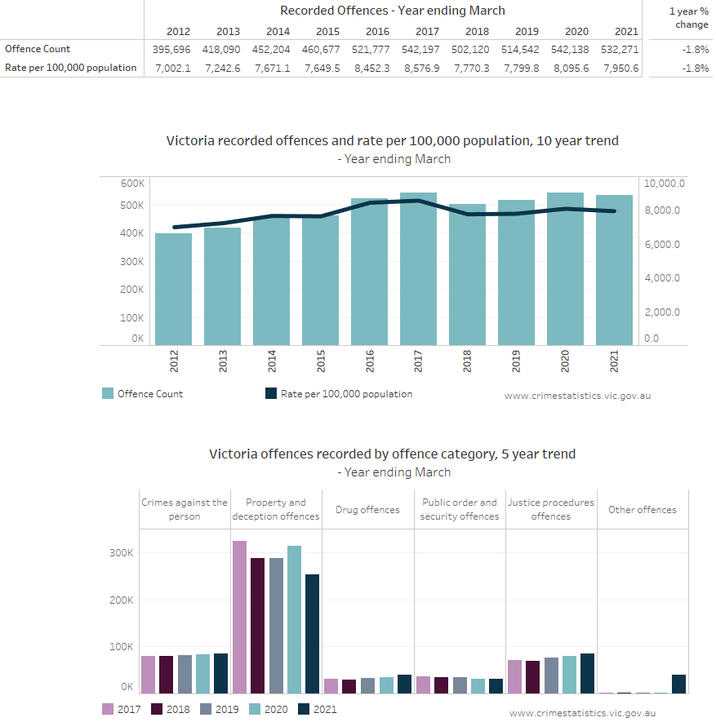
Please note, movements in recorded crime data may be impacted by changes in legislation and operational policing. Information about notable changes is in the Explanatory Notes, refer to this when comparing data over time.

3. Alleged offender incidents
An alleged offender incident is an event involving one or more offences where a person, business or organisation has been linked as an alleged offender. For more information about counting rules, please refer to the Explanatory Notes.
Since early 2020 Victoria has been responding to the global COVID-19 pandemic through a range of health responses that have included periods of restrictions on people’s movements and daily activities. The health response was supported by the introduction of new COVID-19-related offences codes relating to breaches of Chief Health Officer (CHO) Directions the Public Health and Wellbeing Act 2008. The restrictions on movement and introduction of breaches of CHO directions had a flow on effect for Victorian recorded crime, and this differed by crime type. For more information about the impacts of COVID-19 on crime please see the CSA paper Police-recorded crime trends in Victoria during the COVID-19 pandemic: update to the end of December 2020.
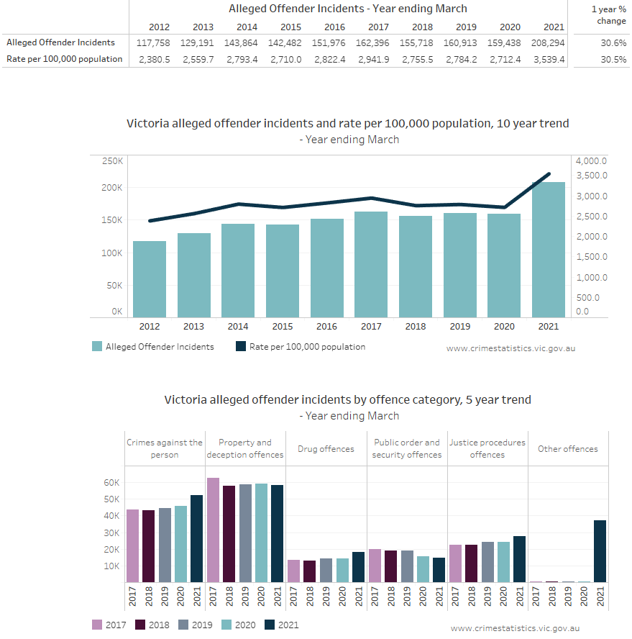
Please note that movements in recorded crime data may be impacted by changes in legislation and operational police practice. Information is available about notable changes in the Explanatory Notes, refer to this information when comparing data over time.

4. Victim reports
A victim report is counted when an individual, business or organisation is recorded on LEAP as being a victim of one or more criminal offences. For more information about counting rules, please refer to the Explanatory Notes.
Since early 2020 Victoria has been responding to the global COVID-19 pandemic through a range of health responses that have included periods of restrictions on people’s movements and daily activities. The health response was supported by the introduction of new COVID-19-related offences codes relating to breaches of Chief Health Officer (CHO) Directions the Public Health and Wellbeing Act 2008. The restrictions on movement and introduction of breaches of CHO directions had a flow on effect for Victorian recorded crime, and this differed by crime type. For more information about the impacts of COVID-19 on crime please see the CSA paper Police-recorded crime trends in Victoria during the COVID-19 pandemic: update to the end of December 2020.
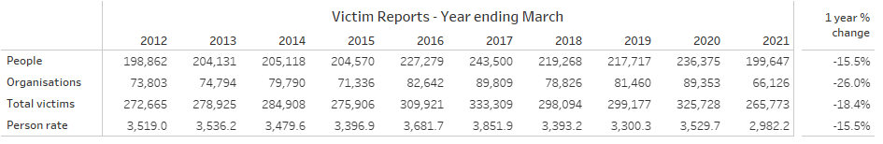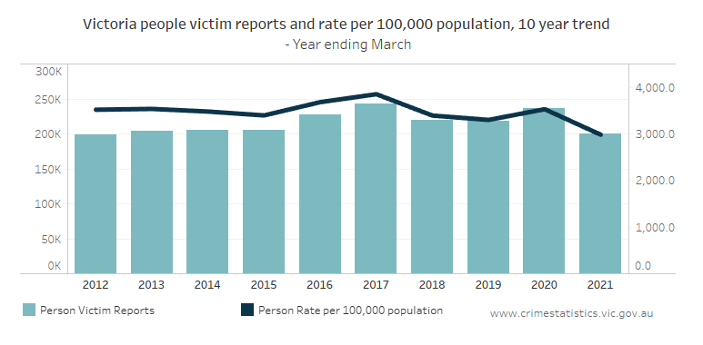
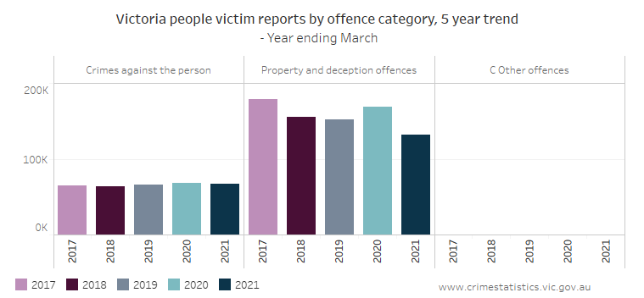
Please note that movements in recorded crime data may be impacted by changes in legislation and operational police practice. Information is available about notable changes in the Explanatory Notes, refer to this information when comparing data over time.

5. Family incidents
A family incident is an incident attended by Victoria Police where a Victoria Police Risk Assessment and Risk Management Report (also known as an L17 form) was completed and recorded on LEAP. For more information about counting rules, please refer to the Explanatory Notes.
Since early 2020 Victoria has been responding to the global COVID-19 pandemic through a range of health responses that have included periods of restrictions on people’s movements and daily activities. The health response was supported by the introduction of new COVID-19-related offences codes relating to breaches of Chief Health Officer (CHO) Directions the Public Health and Wellbeing Act 2008. The restrictions on movement had flow on effects for Victorian family violence incidents. For more information about the impacts of COVID-19 on crime please see the CSA paper Police-recorded crime trends in Victoria during the COVID-19 pandemic: update to the end of December 2020.
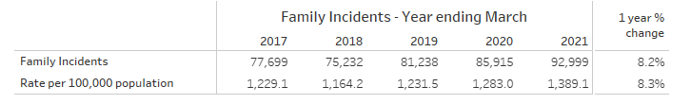
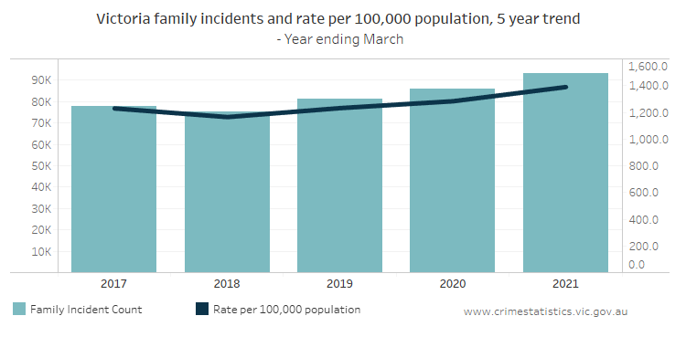
Affected family members
An ‘affected family member’ is the individual who is deemed to be affected by events occurring during a family incident. For more information about counting rules, please refer to the Explanatory Notes.
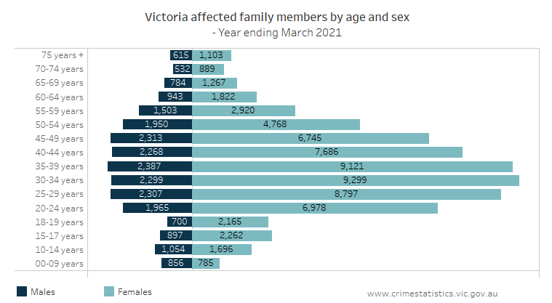
Other party
The other individual involved in a family incident is referred to as the ‘other party’. The other party could be a current partner, former partner or a family member. For more information about counting rules, please refer to the Explanatory Notes.
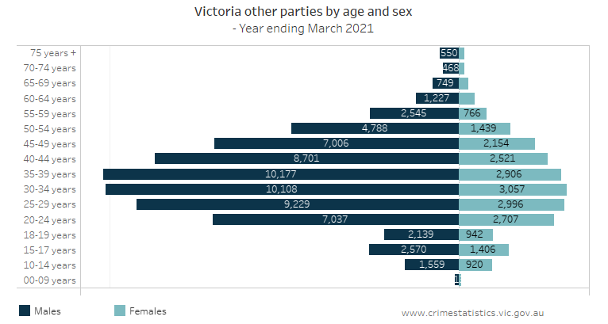
In response to COVID-19 Victoria Police commenced Operation Ribbon on 13 April 2020. Operation Ribbon focused specifically on active engagement with victim-survivors and known perpetrators of family violence. Operation Ribbon involved specialist detectives from the Family Violence Investigation Units across the state reaching out to Victorians perceived to be at greater risk of family violence due to the impacts of COVID-19 and associated public health measures, including restricted movement. Incidents relating to specific operations that are recorded in the LEAP database are often not easily identifiable. For more information about the impacts of COVID-19 on crime please see the CSA paper Police-recorded crime trends in Victoria during the COVID-19 pandemic: update to the end of December 2020.

6. Alleged offender incidents by Aboriginal and Torres Strait Islander status
An alleged offender incident is an incident involving one or more offences where an individual, business or organisation has been recorded as an alleged offender. For more information about counting rules, please refer to the Explanatory Notes.
Aboriginal or Torres Strait Islander status for alleged offender incidents are based on the most frequent recording of the Indigenous status for each offender. Under this counting rule, a person has either a yes or no response to the Standard Indigenous Question (SIQ) on their record, then the most frequent recorded response is taken as correct. If the person only has one meaningful response, then that response stands across all records. If a person appears in the dataset two different times with a ‘yes’ and a ‘no’ in the records, a ‘yes’ response is taken over a ‘no’ response. For more information on how this counting rule operates see the Explanatory Notes.
For the purposes of the presentation of these data the term Aboriginal refers to the most frequent response a person has provided to Victoria Police when the SIQ was asked (Aboriginal or Torres Strait Islander status).
Since early 2020 Victoria has been responding to the global COVID-19 pandemic through a range of health responses that have included periods of restrictions on people’s movements and daily activities. The health response was supported by the introduction of new COVID-19-related offences codes relating to breaches of Chief Health Officer (CHO) Directions the Public Health and Wellbeing Act 2008. The restrictions on movement and introduction of breaches of CHO directions had a flow on effect for Victorian recorded crime, and this differed by crime type. For more information about the impacts of COVID-19 on crime please see the CSA paper Police-recorded crime trends in Victoria during the COVID-19 pandemic: update to the end of December 2020.
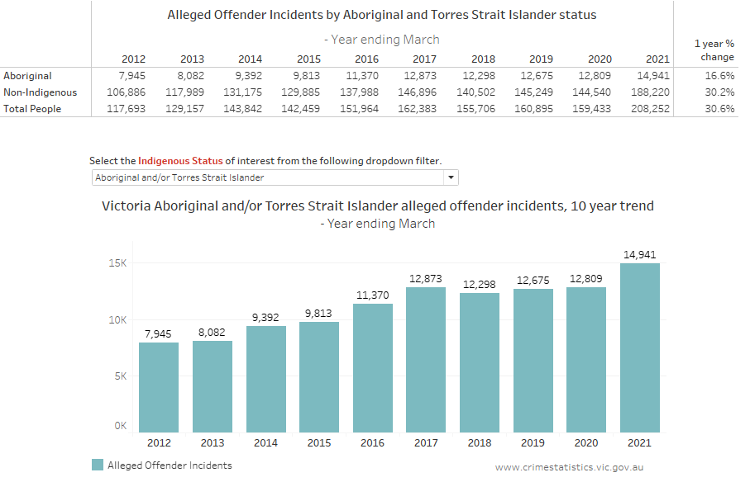

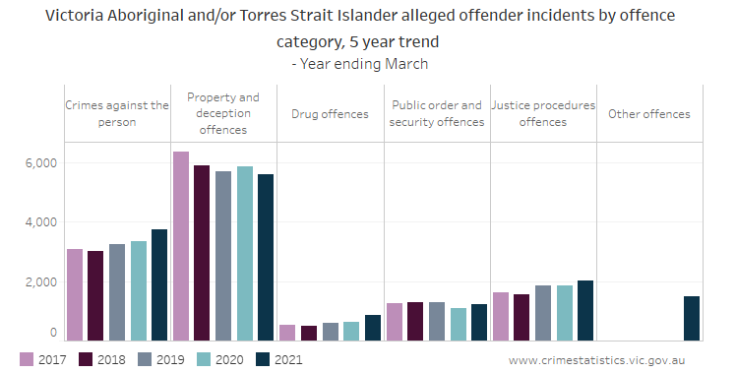

Please note that movements in recorded crime data may be impacted by changes in legislation and operational police practice. Information is available about notable changes in the Explanatory Notes, refer to this information when comparing data over time.

7. Family incidents by Aboriginal and Torres Strait Islander status
A family incident is an incident attended by Victoria Police where a Victoria Police Risk Assessment and Risk Management Report (also known as an L17 form) was completed and recorded on LEAP. For more information about counting rules, please refer to the Explanatory Notes.
Aboriginal or Torres Strait Islander status for affected family members and other parties are based on the most frequent recording of the Indigenous status for each offender. Under this counting rule, a person has either a yes or no response to the Standard Indigenous Question (SIQ) on their record, then the most frequent recorded response is taken as correct. If the person only has one meaningful response, then that response stands across all records. If a person appears in the dataset two different times with a ‘yes’ and a ‘no’ in the records, a ‘yes’ response is taken over a ‘no’ response. For more information on how this counting rule operates see the Explanatory Notes.
For the purposes of the presentation of these data the term Aboriginal refers to the most frequent response a person has provided to Victoria Police when the SIQ was asked (Aboriginal or Torres Strait Islander status).
Since early 2020 Victoria has been responding to the global COVID-19 pandemic through a range of health responses that have included periods of restrictions on people’s movements and daily activities. The health response was supported by the introduction of new COVID-19-related offences codes relating to breaches of Chief Health Officer (CHO) Directions the Public Health and Wellbeing Act 2008. The restrictions on movement and introduction of breaches of CHO directions had a flow on effects for Victorian family violence incidents. For more information about the impacts of COVID-19 on crime please see the CSA paper Police-recorded crime trends in Victoria during the COVID-19 pandemic: update to the end of December 2020.
Affected family members by Aboriginal and Torres Strait Islander status
An ‘affected family member’ is the individual who is deemed to be affected by events occurring during a family incident. For more information about counting rules, please refer to the Explanatory Notes.
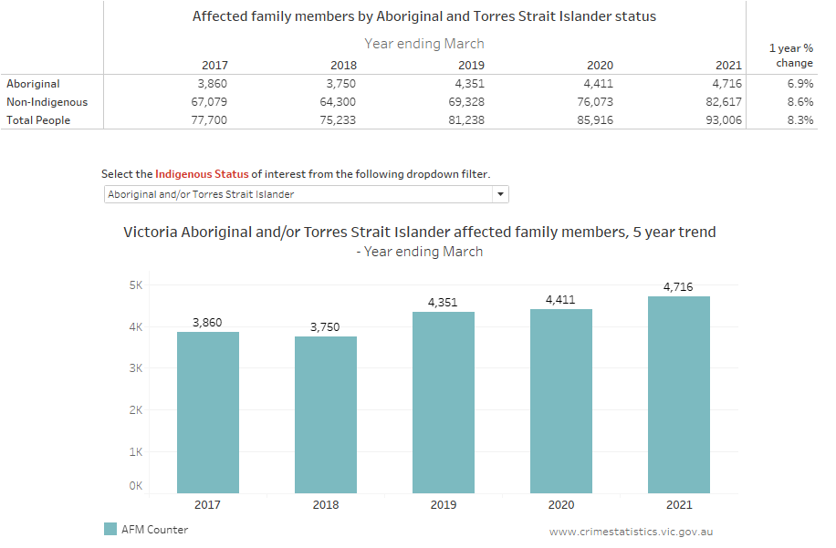
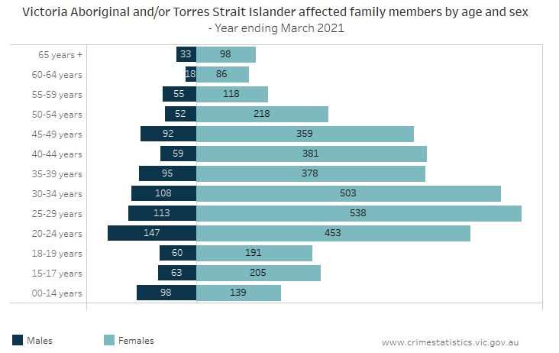
Other parties by Aboriginal and Torres Strait Islander status
The other individual involved in a family incident is referred to as the ‘other party’. The other party could be a current partner, former partner or a family member. For more information about counting rules, please refer to the Explanatory Notes.
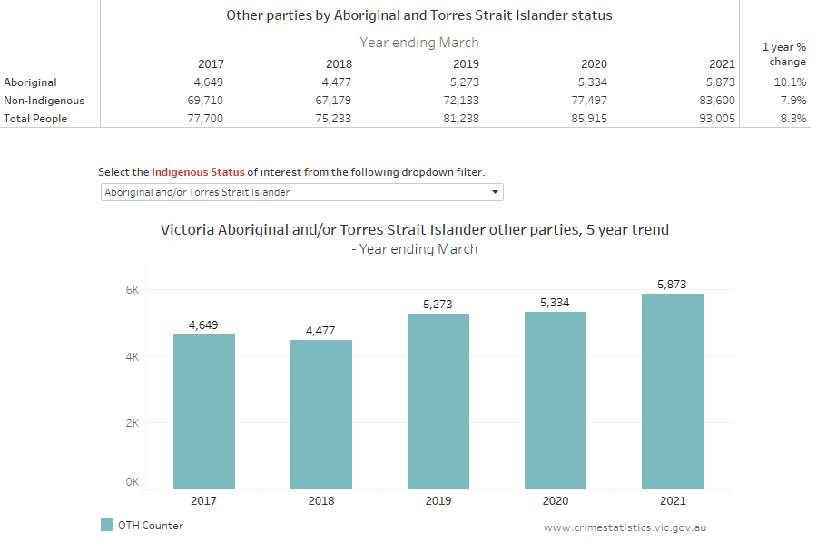
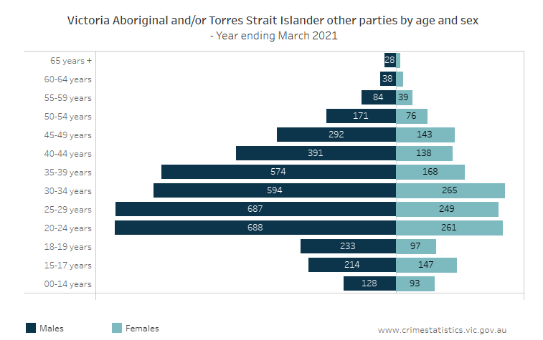
In response to COVID-19 Victoria Police commenced Operation Ribbon on 13 April 2020. Operation Ribbon focused specifically on active engagement with victim-survivors and known perpetrators of family violence. Operation Ribbon involved specialist detectives from the Family Violence Investigation Units across the state reaching out to Victorians perceived to be at greater risk of family violence due to the impacts of COVID-19 and associated public health measures, including restricted movement. Incidents relating to specific operations that are recorded in the LEAP database are often not easily identifiable. For more information about the impacts of COVID-19 on crime please see the CSA paper Police-recorded crime trends in Victoria during the COVID-19 pandemic: update to the end of December 2020.

