Research Agenda 2019-21

Background
In addition to regular statistical reporting, the Crime Statistics Agency (CSA) has a legislated function to conduct research into crime and criminal justice trends and issues. The overarching objective of the CSA’s research program is to identify and influence opportunities for policy development and reform to ensure that Victoria’s justice system responses are underpinned by robust evidence.
The CSA’s research aims to be objective, timely, transparent and accessible to stakeholders. Priority is given to research projects that have clear practical applications.
Purpose
The purpose of the Research Agenda is to outline areas of interest that will shape the CSA’s research efforts over the next three years. These are areas where the CSA, given our data assets and expertise, can foreseeably have the largest impact in terms of supporting evidence-based justice policy and program design for Victoria into the future. The Research Agenda will be used as a foundation for the development of customised research projects. The Research Agenda also provides a basis for research collaboration with other agencies who have a mutual interest in conducting research and evaluation in identified areas.
Development
The Research Agenda has been developed based on consultation with key Government and non-Government stakeholders, and in response to data and research requests made to the CSA on an ongoing basis. Literature scanning in emerging areas of interest was also conducted to supplement information provided by stakeholders.
Next steps
The CSA will develop and conduct customised research projects in line with the Research Agenda, for publication through a range of channels. Development of research methodologies will also form part of the research program going forward, and will ensure that complex research questions can continue to be answered. The CSA welcomes collaborations with academics and research organisations with mutual areas of interest. The Agenda will be reviewed on an annual basis to ensure continued relevance over the next three years.

Research Agenda
Figure 1 shows the framework for the CSA’s Research Agenda for 2019–21. The framework includes a series of four Research Themes, which are designed to ensure that CSA research is relevant to policymakers, and offers valuable contributions to the available evidence base for various aspects of policy making and program design. The CSA aims to conduct research that is directly relevant to one or more of these themes.

Five Priority Areas have also been identified, which overlap with the themes to provide a specific focus for the research projects that will be conducted at the CSA over the next three years. These are crime and justice topics where the CSA has identified that research is required to help fill gaps in the existing evidence base available to policymakers. Each Research Theme and Priority Area is described in detail below.

Figure 1. Research Agenda framework
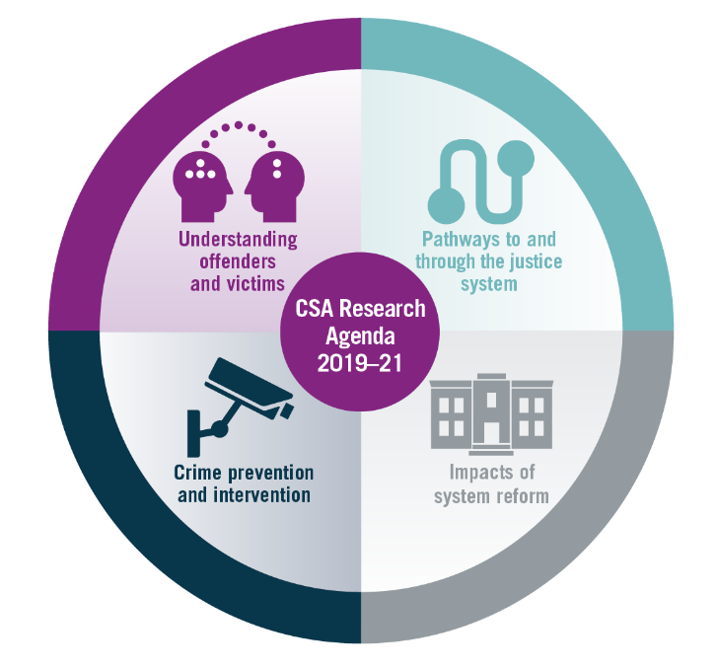
Research Themes
1. Understanding offenders and victims
Stakeholders identified that there are particular cohorts of Victorian offenders and victims about whom little is known. Increasing our understanding of these cohorts, including their characteristics, behavioural patterns and offending or victimisation histories will enable increased effectiveness in the targeting and design of intervention programs to address offending and victimisation. This includes developing an understanding of local contexts and individual needs that may impact on offending and victimisation.

2. Pathways to and through the justice system
Multiple studies have identified that appearing in the criminal justice system is the culmination of a pattern of disadvantage and social service contact (Kurlychek & Johnson, 2019). Considering the points at which individuals have contact with various agencies, the points at which they first have contact with the justice system and their patterns of contact with the various agencies that make up the justice and broader social service systems over time will provide insights into:
• Opportunities for early intervention across cohorts of victims and offenders.
• Potential intervention points to circumvent escalation in offending.
• Opportunities for coordination of programs across agencies, to enable integrated responses and service delivery.
3. Crime prevention and intervention
The focus of this research theme is on the identification and evaluation of crime prevention and intervention strategies and programs. Stakeholders highlighted that there may also be opportunities to identify gaps in the availability, provision and take-up of intervention programs based on individual offender and victim needs.

CSA work in this area will focus on identifying or generating robust evaluations to ensure the underlying evidence base on effective interventions to reduce offending and victimisation is strengthened. It will also consider specific cohorts for whom interventions are effective, and the local contexts in which they are most likely to be effective.

Where possible, CSA crime prevention and intervention research will also consider the economic implications of particular programs, and the contribution of individual programs and policies to outcomes in the context of multi-agency service delivery.
4. Impacts of system reform
Justice system and broader cross-governmental reform, including legislative and policy changes can impact on the number and nature of crimes dealt with by the criminal justice system and the required responses for addressing those crimes. In turn, system reform can affect the level of demand placed on various agencies across the justice system.

The CSA will conduct research to examine whether and how significant reforms impact on crime and responses to crime and on outcomes for offenders. Stakeholders also said that they were broadly interested in whether and how reform, and particularly legislation change, impacts on behaviour change amongst individuals in the community and this also represents a potential avenue for further research inquiry.

Priority Areas
1. Women and girls
The number of women in prison has risen substantially since 2012. The total number of women in prison rose by 49% in the five years to June 2017 (Corrections Victoria, 2019). This trend is not unique to Victoria (Jeffries & Newbold, 2016). A recent New South Wales Study identified that a substantial increase in the number of repeat female offenders appearing before a court and a smaller increase in the number of women proceeded against by police have contributed to similar increases there (Ooi, 2018). However, no research has been conducted to identify the drivers of the increases in Victoria, and stakeholders identified this as an important area for upcoming CSA research. Projects will consider the extent to which women in prison may be committing more serious or frequent offences compared with previously, or whether justice system responses to women’s offending have changed over time. This research may also lead to increased understanding about female prisoners’ multiple and complex needs.

Additionally, though they represent a minority of youth offenders, it was reported that little is known about girls who have contact with the criminal justice system, including their life course trajectories; potential needs (including how these needs differ from those of young male offenders); and interventions that may be appropriate to address those needs.
2. Legislation change
CSA research on legislation change over the next three years will focus on system and individual impacts resulting from major recent legislative changes, with a particular emphasis on changes to bail legislation. Since 2012, a large number of amendments have been made to the Bail Act 1977 (VIC). These changes have made it more difficult for alleged offenders to be granted bail. Most recently, a Bail Review undertaken by the Hon Paul Coghlan QC in 2017 recommended two stages of changes to the Act, which were subsequently implemented by the Victorian Government in 2017 and 2018.

CSA stakeholders highlighted concerns that these amendments may have had unintended consequences, such as putting additional demand on Victoria’s prison system through increases in the remand population. Additionally, stakeholders noted that making it more difficult for individuals to access bail may serve to increasingly criminalise vulnerable cohorts. CSA research on bail will therefore examine the impacts of the bail legislation changes on community safety, on demand across the justice system and on individual outcomes for alleged offenders.

3. Family violence
There remains limited evidence available about certain cohorts of family violence perpetrators and victims. CSA research will aim to strengthen our understanding of a number of these cohorts, including male victims of family violence and adolescent perpetrators of family violence.

While the vast majority of family violence victims are female, there is preliminary evidence to suggest that circumstances surrounding family violence differ significantly for male and female victims, providing a rationale to investigate the characteristics and experiences of these groups independently of one another. Related to our research on male victims of family violence, we will also consider the extent to which reciprocal violence occurs within relationships, and whether this has implications for the identification of primary aggressors, as suggested by the Royal Commission into Family Violence (RCFV; State of Victoria, 2016) and other recent reports (Ulbrick & Jago, 2018).

The RCFV noted that adolescent family violence is a distinct form of family violence, and emphasised a general lack of awareness and understanding of this type of family violence in the community and amongst service providers. CSA stakeholders commented that as a result there is very limited information to draw on in the design and targeting of programs to address adolescent family violence. It was also noted that there are no programs currently available for adolescents who perpetrate violence against their intimate partners, and that this group may represent a distinct subset of adolescent family violence perpetrators.

Recent research indicates that Australian studies examining the effectiveness of family violence protection orders are lacking, particularly for Aboriginal and Torres Strait Islander victims (Dowling et al., 2018). Stakeholders expressed interest in CSA research examining the effectiveness of Victorian intervention orders on perpetrator behaviour and victim safety, including analysis of the frequency and nature of intervention order breaches.

Additional areas of research identified through the consultation included:
1. Serial perpetrators of family violence, or those who perpetrate violence against multiple partners or other victims over time.
2. Victims who experience family violence perpetrated by multiple people over time.
3. Family violence perpetrators who perpetrate violence against multiple victims simultaneously (including an exploration of the characteristics of victims).
4. How prior family violence victimisations impact on propensity for future victimisation and/or perpetration.
4. Sexual offences
The rate of sexual offences recorded in Victoria increased by 64% over the past ten years, reaching 217 offences per 100,000 population in 2018 (Crime Statistics Agency, 2019). This trend is not unique to Victoria, with the Australian Bureau of Statistics recently reporting national increases in recorded sexual assault victimisation rates (ABS, 2018).

Stakeholders discussed potential drivers of the observed increases, but noted that to date there are no studies examining the drivers of the increases and that such research is warranted. Potential drivers that will be explored by CSA research include:
1. The introduction of new types of sexual offences related to image based abuse, which came into effect in 2014,
2. Family violence related sexual offending,
3. Comparing increases in reporting of sexual offences compared with increases in incidence of these offence types,
4. The extent to which major events, such as the Royal Commission into Institutional Child Sexual Abuse, may drive increased reporting.

The CSA has previously conducted research into the likelihood that sexual offences reported to police will progress through each stage of the criminal justice process and eventually be heard and proven in court (Millsteed and McDonald, 2017). Overall, the study identified that just under a quarter of sexual offences recorded by Victoria Police in 2009 and 2010 were heard in court. Stakeholders noted that Victoria Police rolled out Sexual Offences and Child Abuse Investigation Teams (SOCITS) state wide in 2012. These teams provide a specialist response to victims of sexual offences, and may have increased the likelihood that an offence progresses through the justice system. An update to the CSA’s prior research using more recent data was suggested as one way of evaluating the effect of SOCITS on the progression of offences through the justice system.
5. Youth crime
There is a need to continue to examine young people’s contacts with the justice system and the outcomes of those contacts. Previous CSA research has examined the frequency and impact of child cautions issued by police (Shirley, 2017), but stakeholders have identified a need to examine other police and justice system responses to youth crime. In particular, CSA research in this area will focus on the extent to which young people go on to be charged and appear in court for the offences they are initially alleged to have committed.

A recent review has prompted significant reform to the youth justice system (Armytage and Ogloff, 2017). New programs and justice options for addressing youth offending have commenced operation as a result, and stakeholders emphasised the importance of ensuring these programs are adequately and robustly evaluated. In addition to examining police responses to youth crime, the CSA will seek opportunities to evaluate outcomes for young people associated with court, community and custodial-based programs. Stakeholders particularly emphasised their interest in the outcomes associated with Children’s Court Youth Diversions, which were implemented in January 2017 and Youth Control Orders, which were implemented as a new sentencing option in June 2018.

Additionally, stakeholders noted a need to develop an in depth understanding of young people’s pathways into the youth justice system, with a particular focus on patterns of disengagement from school, how disengagement from school is related to offending, and the circumstances in which this leads to eventual contact in with the youth justice system.

Our research on girls in the criminal justice system and on adolescent family violence perpetrators will also broadly contribute to increasing our understanding of youth crime and youth contact with the justice system.

References
ABS (2018). 4510.0 – Recorded Crime – Victims, Australia, 2017. Available at: http://www.abs.gov.au/ausstats/abs@.nsf/mf/4510.0 [Accessed 1 Apr. 20119].

Armytage, P. & Ogloff, J. (2017). Youth Justice Review and Strategy: Meeting needs and reducing offending. Melbourne: Victorian Government.

Corrections Victoria (2019). Women in the Victorian Prison System. Melbourne: Department of Justice and Community Safety.

Crime Statistics Agency (2019). Latest Crime Data: Recorded offences. Available at: https://www.crimestatistics.vic.gov.au/crimestatisticslatest-crime-data/recorded-offences [Accessed 1 Apr. 2019].

Dowling, C., Morgan, A., Hulme, S., Manning, M. & Wong, G. (2018). Protection orders for domestic violence: A systematic review. Trends & issues in crime and criminal justice, No. 551, Canberra: Australian Institute of Criminology.

Jeffries, S. & Newbold, G. (2016). Analysing trends in the imprisonment of women in Australia and New Zealand. Psychiatry, Psychology and Law, 23(2), 184-206.

Kurlychek, M. & Johnson, B. (2019). Cumulative disadvantage in the American Criminal Justice System. Annual Review of Criminology, 2:291-319.

Millsteed, M. & McDonald C. (2017). Attrition of sexual offence incidents across the Victorian criminal justice system. Melbourne: Crime Statistics Agency.

Ooi, E. (2018). Recent Trends in the NSW Female Prison Population. NSW: BOCSAR.

State of Victoria (2016). Royal Commission into Family Violence: Report and recommendations. Melbourne.

Shirley, K. (2017). The cautious approach: Police cautions and the impact on youth reoffending. Melbourne: Crime Statistics Agency.

Ulbrick, M. & Jago, M. (2018). “Officer she’s psychotic and I need protection”: Police misidentification of the ‘promary aggressor’ in family violence incidents in Victoria. Policy Paper 1. Melbourne: Women’s Legal Service Victoria.

Authorised and published by the Crime Statistics Agency, 121 Exhibition Street, Melbourne. This work is licensed under a Creative Commons 4.0 International License. When reporting CSA data and publications, you must attribute the Crime Statistics Agency (or CSA) as the source. If you would like to receive this publication in an accessible format such as large print or audio, telephone 03 8684 1808 or email info@crimestatistics.vic.gov.au

